
AD23401
DATA EXPLORATION AND VISUALIZATION

A PRACTICAL RECORD

Submitted By

Dhanalakshmi A
2023510019
B.Tech Artificial Intelligence and Data Science(4/8)

DEPARTMENT OF INFORMATION TECHNOLOGY MADRAS INSTITUTE OF TECHNOLOGY ANNA UNIVERSITY, CHENNAI – 600 044

January – May 2025

BONAFIDE CERTIFICATE

Name : Dhanalakshmi A
Register No. : 2023510019
Subject : AD23401 Data Exploration and Visualization
Branch : Artificial Intelligence and Data Science

Certified to the bonafide record of practical work done by Ms. Dhanalakshmi A in the AD23401 Data Exploration and Visualization during the period January 2025 to May 2025.

Date:
Dr Radha Senthil Kumar
STAFF-IN-CHARGE

Submitted for the Practical Examination held on:

Internal Examiner External Examiner

LIST OF EXPERIMENTS

Exp. No | Date | Name of the Experiment | Page | Signature
1 | 21/01/25 | EXPLORING PYTHON PACKAGES | 1
2 | 27/01/25 | DESCRIPTIVE STATISTICS | 11
3 | 03/02/25 | DATA QUALITY | 17
4 | 10/02/25 | STORYTELLING WITHOUT AND WITH DATA | 23
5 | 18/02/25 | ANALYZING PERSONAL EMAIL DATA | 28
6 | 03/03/25 | INSTALLATIONS AND THE STEPS FOR PACKAGES | 34
7 | 10/03/25 | FEATURE IDENTIFICATION FOR TARGET PREDICTION | 37
8 | 17/03/25 | IDENTIFYING AND UNDERSTANDING GROUPS, BUILDING MODELS FROM DATA | 41
9 | 25/03/25 | DATA AND CLUSTER ANALYSIS ON HAPPINESS & E-COMMERCE | 45
10 | 03/04/25 | DATA VISUALISATION | 54
11 | 07/04/25 | TEXT AND DOCUMENT VISUALIZATION, TEXT ANALYSIS AND VISUALIZATION SYSTEMS | 63

EX. NO: 01  21 .01 .25 | EXPLORING PYTHON PACKAGES
AIM:
To explore various python packages like pandas , numpy, seaborn , etc.

Pandas:
Pandas is an open source, BSD-licensed library providing high-performance, easy-to-use data structures and data analysis tools for the Python programming language.

CODE:
import pandas as pd
df=pd.read_csv("penguins.csv")
df.head()
OUTPUT:
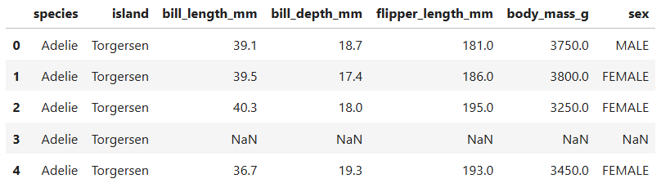

CODE:
df.shape

OUTPUT:
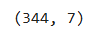

CODE:
df.head(10)

OUTPUT:
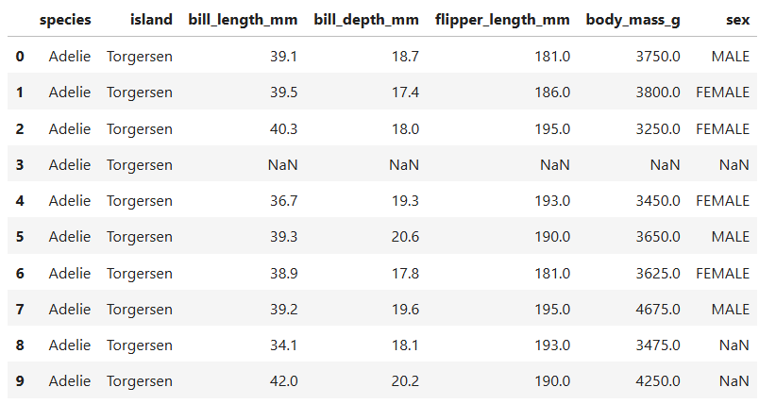
CODE:
df.isnull()

OUTPUT:
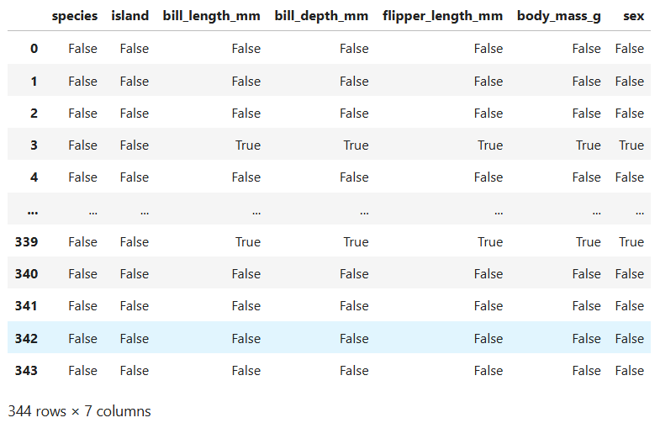

CODE:
df.describe()

OUTPUT:
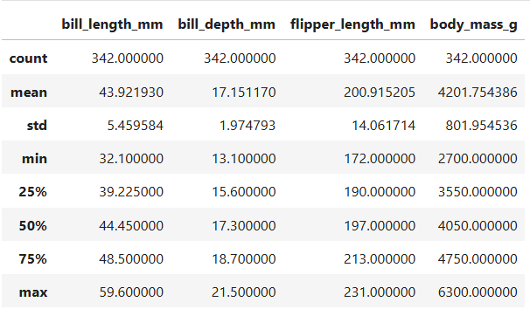

CODE:
d=df.drop("sex",axis=1)
d.head()

OUTPUT:
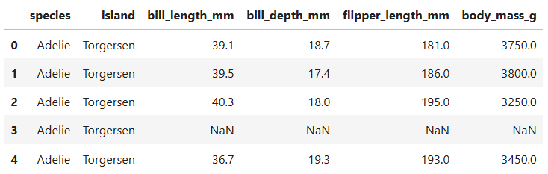

CODE:
df["bill_length_mm"]=df["bill_length_mm"].fillna(df["bill_length_mm"].mean())
df["bill_depth_mm"]=df["bill_depth_mm"].fillna(df["bill_depth_mm"].mean())
df["flipper_length_mm"]=df["flipper_length_mm"].fillna(df["flipper_length_mm"].mean())
df["body_mass_g"]=df["body_mass_g"].fillna(df["body_mass_g"].mean())
df.query('body_mass_g > 6000')

OUTPUT:
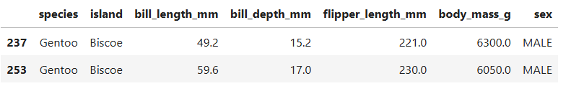

CODE:
s={"AREA":3.14*df["bill_length_mm"]*df["bill_depth_mm"]}
d_new=pd.DataFrame(s)
d_new.head()

OUTPUT:
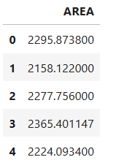

Numpy:
NumPy is the fundamental package for scientific computing in Python. It is a Python library that provides a multidimensional array object, various derived objects (such as masked arrays and matrices), and an assortment of routines for fast operations on arrays, including mathematical, logical, shape manipulation, sorting, selecting, I/O, discrete Fourier transforms, basic linear algebra, basic statistical operations, random simulation and much more.

CODE:
import numpy as np
d1=np.array(range(1,10))
d1

OUTPUT:
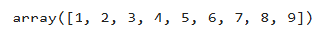

CODE:
d1.reshape(3,3)

OUTPUT:
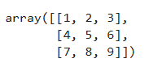

CODE:
print(d1+d1)
print(d1*d1)
print(np.mod(d1,2))

OUTPUT:
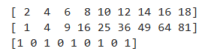

CODE:
np.mean(df["bill_length_mm"])

OUTPUT:
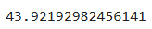

CODE:
np.median(df["bill_length_mm"])

OUTPUT:
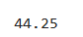

CODE:
np.std(df["bill_length_mm"])

OUTPUT:
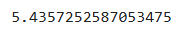

CODE:
d1=d1+10
d1

OUTPUT:
CODE:
d1=d1*100
d1
OUTPUT:

CODE:
d3=np.random.randint(0,2,100)
d3=pd.DataFrame(d3,columns=["coin_flip"])
d3

OUTPUT:
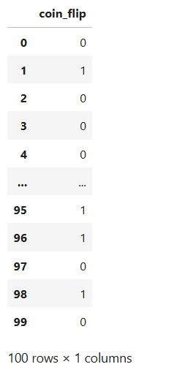

MATPLOTLIB:
Matplotlib is a comprehensive library for creating static, animated, and interactive visualizations in Python. Matplotlib makes easy things easy and hard things possible.

CODE:
import matplotlib.pyplot as plt
x=list(range(-10,10))
y=[i*2 for i in x]
plt.plot(x,y)
plt.xlabel("x -------->")
plt.ylabel("y ---------->")
plt.legend("line")

OUTPUT:
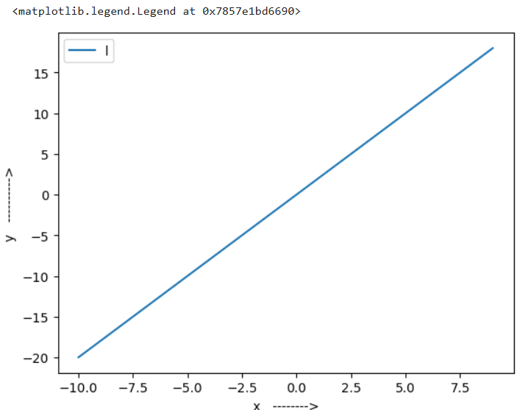
CODE:
import matplotlib.lines as mlines
plt.scatter(df["bill_length_mm"], df["bill_depth_mm"], c=df["species"].map({"Adelie": "blue", "Chinstrap": "red", "Gentoo": "orange"}))
plt.title("bill_length_mm vs bill_depth_mm")
plt.xlabel("bill_length_mm")
plt.ylabel("bill_depth_mm")
legend_labels = ["Adelie", "Chinstrap", "Gentoo"]
colors = ["blue", "red", "orange"]
h = [mlines.Line2D([], [], color=color, label=label,)for color, label in zip(colors, legend_labels)]
plt.legend(handles=h)
plt.show()

OUTPUT:
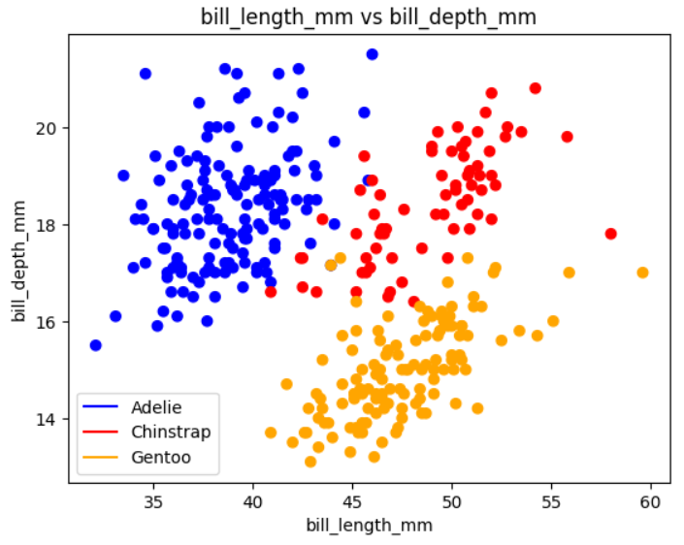
INFERENCE:
Adelie penguins have shorter bills but deeper (taller) ones. Gentoo penguins have longer bills but shallow (less deep) ones.Chinstrap penguins lie in between, with medium-to-long and moderately deep bills.

CODE:
plt.bar(df["species"],df["body_mass_g"])
plt.xlabel("species")
plt.ylabel("body_mass_g")
plt.title("species vs body_mass_g")
OUTPUT:
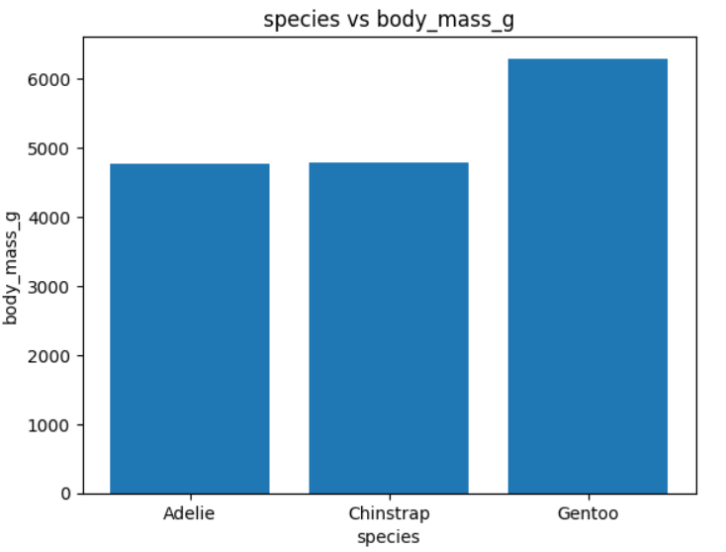
INFERENCE:
Gentoo penguins have the highest average body mass among the three species. Adelie and Chinstrap penguins have similar average body masses.

CODE:
plt.figure(figsize=(10,5))
plt.hist(df["bill_length_mm"],color='black',edgecolor='white')
plt.xlabel("bill_length_mm")
plt.savefig("myImage.png", format="jpeg", dpi=1080)
plt.ylabel("frequency")
plt.title("histogram of bill_length_mm")
OUTPUT:
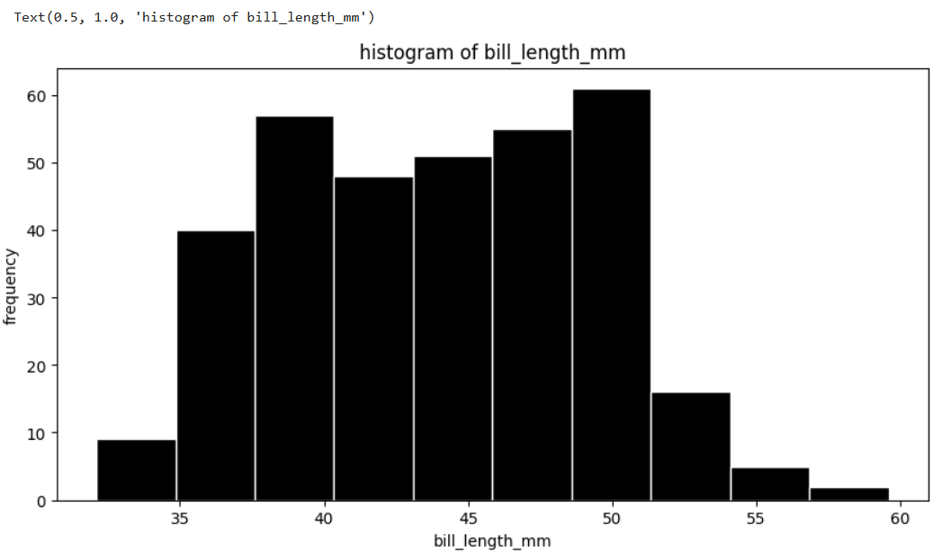
INFERENCE:
The distribution is slightly right-skewed, meaning there are fewer penguins with longer bills (above 52 mm).Most penguins have a moderate bill length, suggesting a central tendency around 45–50 mm.

CODE:
plt.pie(df["species"].value_counts(),labels=df["species"].unique(),autopct='%1.2f%%')
plt.title("pie chart of species")
OUTPUT:
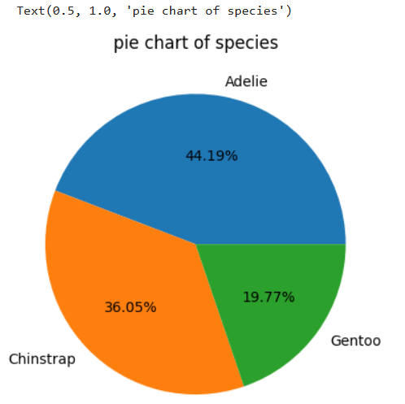
INFERENCE:
Adelie penguins make up the largest portion, accounting for 44.19% of the dataset.Chinstrap penguins are the second most common, with 36.05%.Gentoo penguins are the least represented, making up only 19.77%.
SEABORN:
Seaborn is a library that uses Matplotlib underneath to plot graphs. It will be used to visualize random distributions
CODE:
import seaborn as sns
sns.boxplot(x=df["body_mass_g"])
OUTPUT:
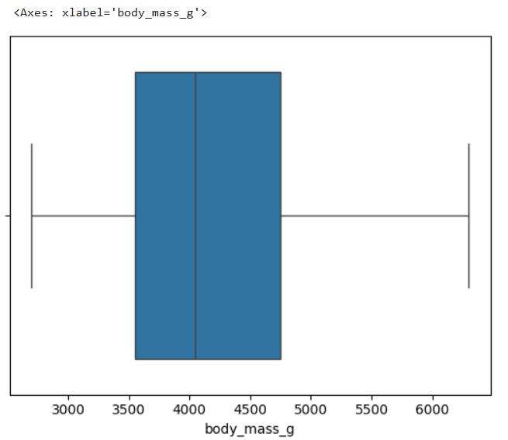
INFERENCE:
The body mass distribution is fairly symmetric, as the median is centered within the box. Most penguins weigh between 3700 g and 4900 g, with a few having either significantly lower or higher weights.

CODE:
sns.pairplot(df,hue='species')
OUTPUT:
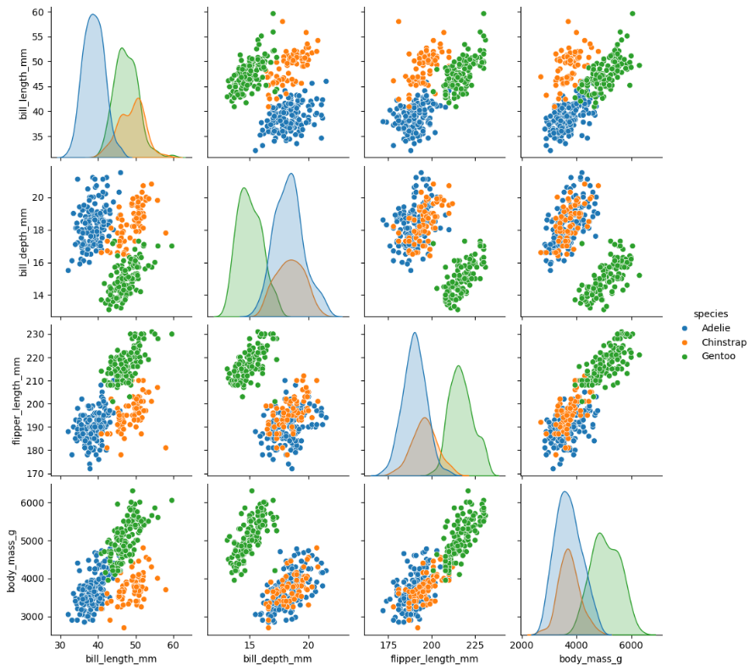
INFERENCE:
Gentoo penguins are generally larger in body mass, flipper length, and bill length. Adelie penguins have shorter bills, flippers, and lower body mass overall. Chinstrap penguins fall in between Adelie and Gentoo in most features.

CODE:
sns.heatmap(df.corr(numeric_only =True))
OUTPUT:
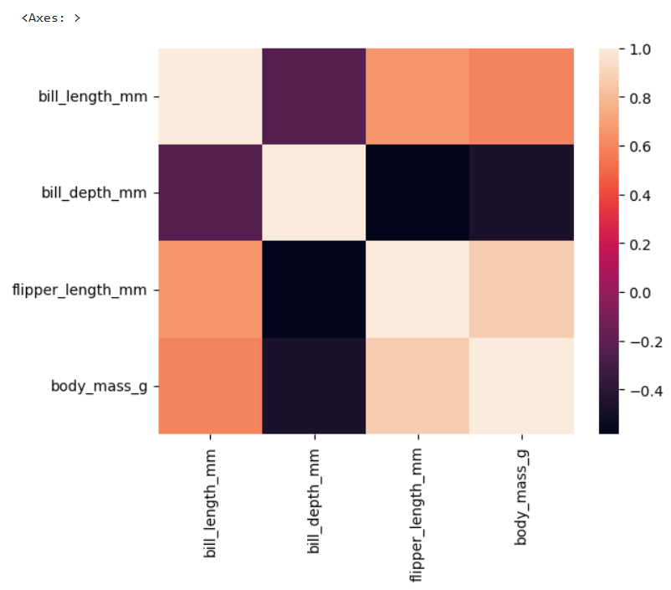
INFERENCE:
Strongest positive correlation: between flipper length and body mass. Strongest negative correlation: between bill depth and flipper length.

CODE:
g=sns.FacetGrid(df,col='species')
g.map(plt.hist,'bill_length_mm')
plt.show
OUTPUT:
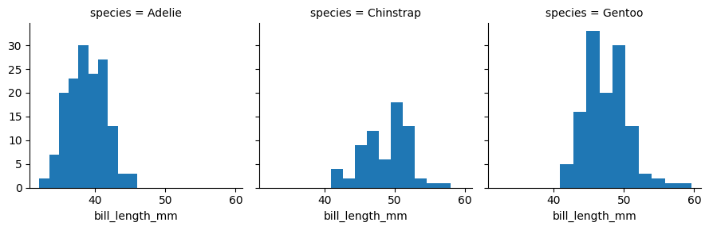
INFERENCE:
Adelie penguins have shorter bills, mostly between 35 mm and 43 mm.Chinstrap penguins have medium bill lengths, mostly between 45 mm and 55 mm.Gentoo penguins have the longest bills, ranging from 40 mm to 60 mm.

CODE:
sns.violinplot(x=df["body_mass_g"],palette=sns.color_palette(),hue=df["species"])

OUTPUT:
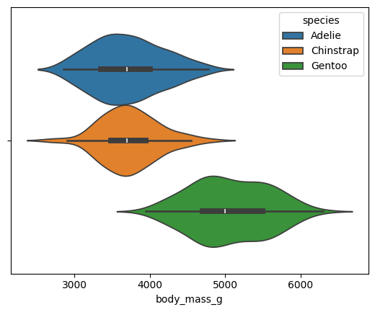

INFERENCE:
Gentoo penguins have the highest body mass, mostly between 4500g and 6000g.Adelie and Chinstrap penguins have lower body mass, mostly around 3500g to 4000g.Chinstrap and Adelie have similar body mass ranges, but Chinstrap is slightly heavier on average.

CODE:
plt.title("hist")
plt.figure.figsize=(10,5)
sns.histplot(df["body_mass_g"],kde='True')

OUTPUT:
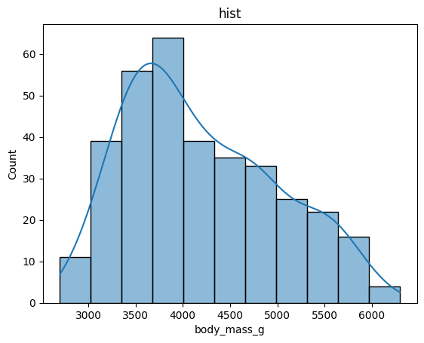
INFERENCE:
Most body masses are between 3500g and 4000g. The data is skewed to the right, meaning fewer individuals have very high body mass.The average body mass is likely around 3700–4000g.

RESULT:
We have explored various python packages.
EX. NO: 02  27 .01 .25 | DESCRIPTIVE STATISTICS
AIM:
To perform descriptive statistics for a dataset.
CODE:
def mean(arr,n):
s=0
for i in range(n):
s+=arr[i]
return s/n
def median(arr,n):
for i in range(n):
for j in range(i+1, n):
if arr[i] >= arr[j]:
# temporary variable
temp = arr[i]
arr[i] = arr[j]
arr[j] = temp
if(n%2==0):
return ((arr[n//2]+arr[n//2+1])/2)
else:
return (arr[(n+1)//2])
def mode(arr,n):
max=0
for i in range(n):
ct=0
for j in range(n):
if(arr[i]==arr[j]):
ct+=1
if(ct>max):
mode=arr[i]
max=ct
return (mode)
def std(arr,n):
sum=0
m=mean(arr,n)
for i in range(n):
sum+=((arr[i]-m)**2)
sd=(sum/n)**(1/2)
return sd
def var(arr,n):
v=std(arr,n)**2
return v
def skew(arr,n):
m=mean(arr,n)
me=median(arr,n)
s=std(arr,n)
sk=(3*(m-me))/s
return sk
def kur(arr,n):
f1=0
m=mean(arr,n)
s=std(arr,n)
for i in range(n):
f1+=(arr[i]-m)**4
frth=f1/n
kur=frth/s**4
return kur

SAMPLE CODE FOR IMPLEMENTING THE FUNCTION:
l=[10,2,30,45,30,5,2,4,34,6,30]
n=len(l)
print("mean : ",mean(l,n))
print("median : ",median(l,n))
print("mode : ",mode(l,n))
print("standard deviation : ",std(l,n))
print("variance : ",var(l,n))
print("skewness : ",skew(l,n))
print("kurtosis : ",kur(l,n))
OUTPUT:
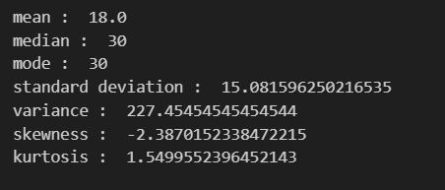
CODE:
import pandas as pd
df=pd.read_csv('wine.csv')
df.head()
OUTPUT:
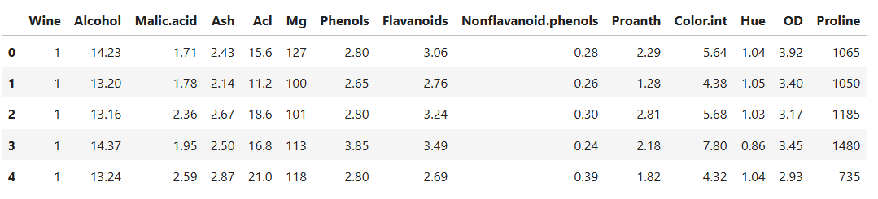
DATASET OVERVIEW:
df.info()
OUTPUT:
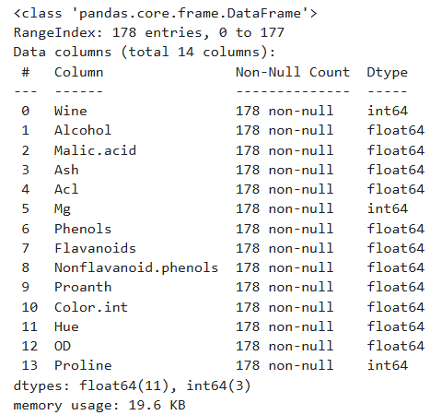
CENTRAL TENDENCY MEASURES:
print('mean : ',mean(df['Proline'],178))
print('mean : ',mean(df['Alcohol'],178))
print('mean : ',mean(df['Mg'],178))
OUTPUT:
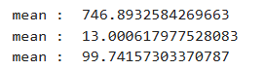
CODE:
import numpy as np
a1=np.array(df['Proline'])
a2=np.array(df['Alcohol'])
a3=np.array(df['Mg'])
print('median : ',median(a1,178))
print('median : ',median(a2,178))
print('median : ',median(a3,178))
OUTPUT:
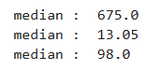
CODE:
print('mode : ',mode(df['Proline'],178))
print('mode : ',mode(df['Alcohol'],178))
print('mode : ',mode(df['Mg'],178))
OUTPUT:
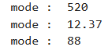

DISPERSION MEASURES:
print('range : ',(df['Proline'].min(),df['Proline'].max()))
print('variance : ',var(df['Proline'],178))
print('standard deviation : ',std(df['Proline'],178))
OUTPUT:
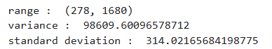

SHAPE OF THE DISTRIBUTION:
a1=np.array(df['Mg'])
print('skewness : ',skew(a1,178))
print('kurtosis : ',kur(a1,178))
OUTPUT:
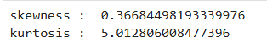
INFERENCE:
Mg is Slightly positively skewed and Leptokurtic (sharper peak and heavier tails than normal)

VISUALIZATION OF DATA:
plt.hist(df['Alcohol'])
OUTPUT:
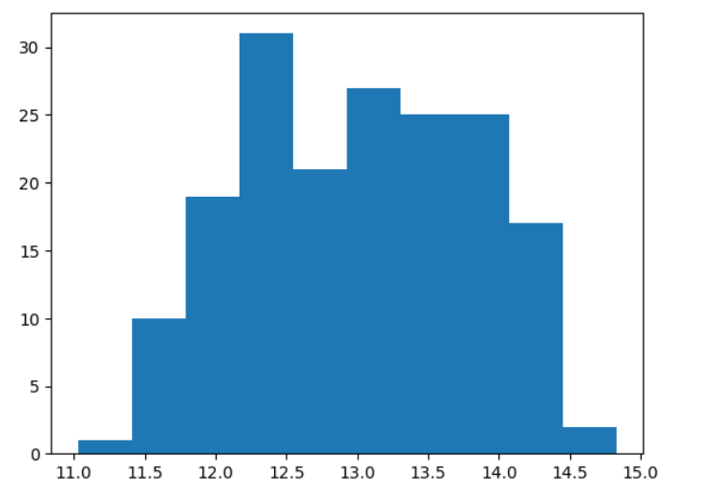
CODE:
plt.boxplot(df['Proline'])
OUTPUT:
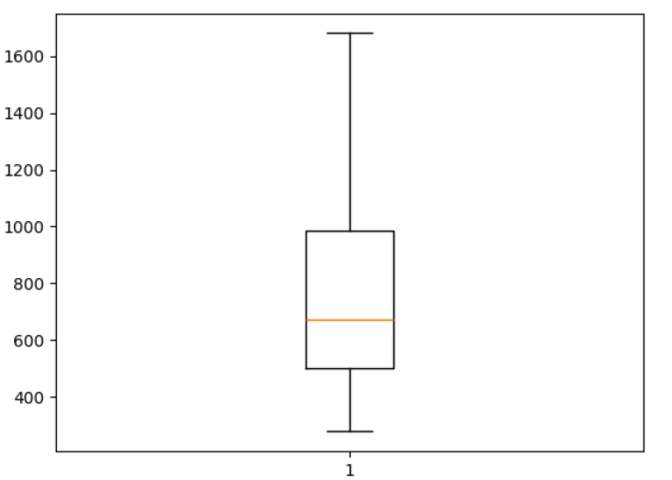

PERCENTILES AND QUARTILES:
q1=df['Mg'].quantile(0.25)
q3=df['Mg'].quantile(0.75)
iqr=q3-q1
print('IQR : ',iqr)
OUTPUT:
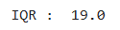
lw=q1-(1.5*iqr)
lw
hi=q3+(1.5*iqr)
hi
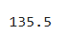
INFERENCE:
Values below 59.5 and above 135.5 are outliers.

CORRELATION BETWEEN VARIABLES:
def cor(arr1,arr2,n):
s1=0
s2=0
s3=0
m1=mean(arr1,n)
m2=mean(arr2,n)
for i in range(n):
s1+=(arr1[i]-m1)*(arr2[i]-m2)
s2+=((arr1[i]-m1))**2
s3+=((arr2[i]-m2))**2
co=s1/((s2*s3)**(1/2))
return co
c=cor(df['Mg'],df['Proline'],178)
print('correlation between proline and mg : ',c)
OUTPUT:
CODE:
import seaborn as sns
sns.scatterplot(x=df['Mg'],y=df['Proanth'],hue=df['Wine'])
OUTPUT:
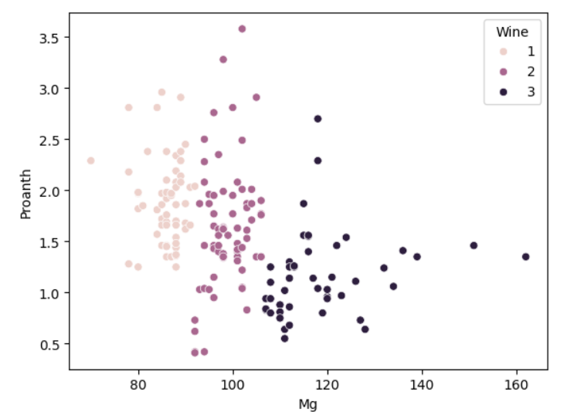
CATEGORICAL DATA SUMMARY:
df['Wine'].value_counts()
OUTPUT:
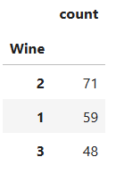
CODE:
df['Wine'].value_counts(normalize=True)
OUTPUT:
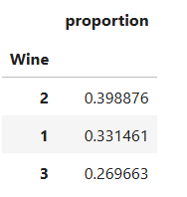
PERCENTAGE:
df['Wine'].value_counts(normalize=True)*100

OUTPUT:
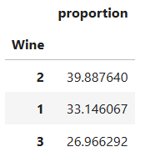

INFERENCE:
from all proline,mg, malic acid are right skewed. IQR is 19.values above 135.5 are outliers.The descriptive statistics provide a comprehensive overview of the wine dataset. Key insights include the central tendency, spread, and shape of different variables. The identification of outliers and the correlation between variables are crucial findings. These insights can guide further analysis, such as feature selection, outlier handling, and model building. For example, the right-skewed distributions of certain variables may suggest transformations to improve model performance. The correlation between 'Mg' and 'Proline' can be further investigated to understand their relationship. Overall, the descriptive statistics form a strong foundation for deeper data exploration and informed decision-making in the context of wine analysis.

RESULT:
We have performed descriptive statistics for a dataset.

EX. NO: 03  03 .02 .25 | DATA QUALITY
AIM:
To Develop a Data Quality Report by programmatically identifying missing values, irregular cardinality, and outliers using Python .

DATA LOADING & PREPROCESSING
import pandas as pd
df=pd.read_csv("city_day.csv")
df.head()
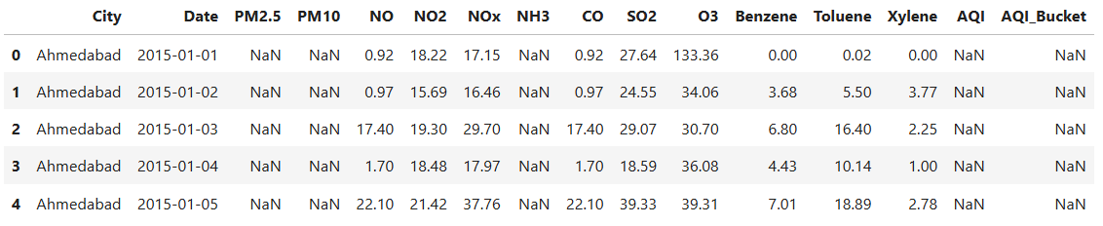
df.info()
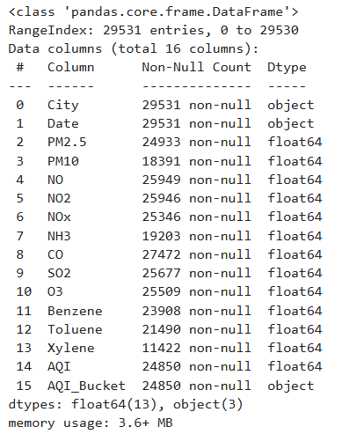
df.describe()
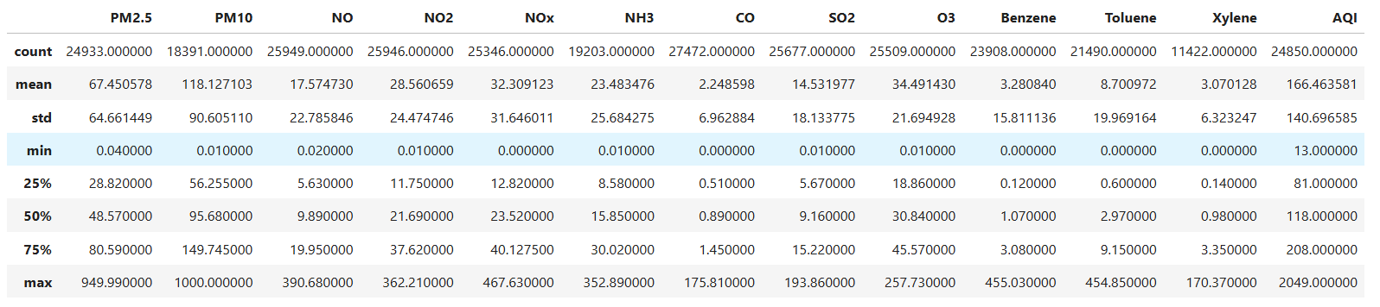

IDENTIFYING MISSING VALUES
import missingno
missingno.heatmap(df)
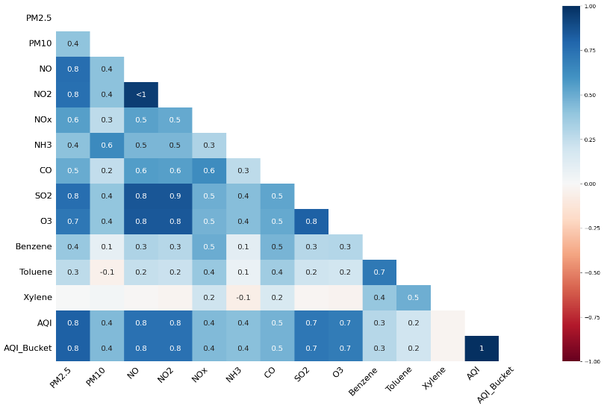
missingno.bar(df)
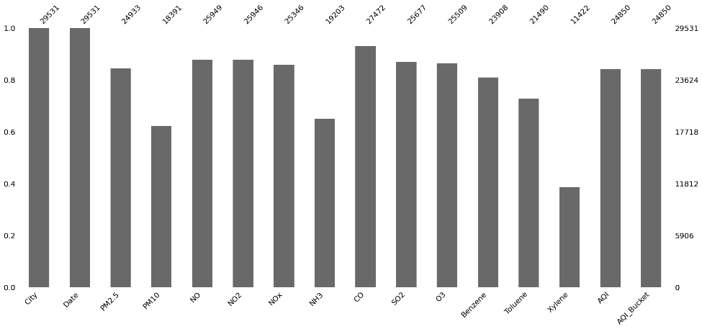
MISSING VALUES IN PERCENT:
print("MISSING VALUES IN % :")
l=len(df)
d0=(((df['City'].isnull().sum())/l)*100).round()
print("City:",d0)
d1=((df['Date'].isnull().sum())/l)*100
print("date:",d1)
d2=(((df['PM2.5'].isnull().sum())/l)*100).round()
print("PM2.5:",d2)
d3=(((df['PM10'].isnull().sum())/l)*100).round()
print("PM10:",d3)
d4=(((df['NO'].isnull().sum())/l)*100).round()
print("NO:",d4)
d5=(((df['NO2'].isnull().sum())/l)*100).round()
print("NO2:",d5)
d6=(((df['NOx'].isnull().sum())/l)*100).round()
print("NOx:",d6)
d7=(((df['NH3'].isnull().sum())/l)*100).round()
print("NH3:",d7)
d8=(((df['CO'].isnull().sum())/l)*100).round()
print("CO:",d8)
d9=(((df['SO2'].isnull().sum())/l)*100).round()
print("SO2:",d9)
d10=(((df['O3'].isnull().sum())/l)*100).round()
print("O3:",d10)
d11=(((df['Benzene'].isnull().sum())/l)*100).round()
print("Benzene:",d11)
d12=(((df['Toluene'].isnull().sum())/l)*100).round()
print("Toluene:",d12)
d13=(((df['Xylene'].isnull().sum())/l)*100).round()
print("Xylene:",d13)
d14=(((df['AQI'].isnull().sum())/l)*100).round()
print("AQI:",d14)
d15=(((df['AQI_Bucket'].isnull().sum())/l)*100).round()
print("AQI_Bucket:",d15)
OUTPUT:
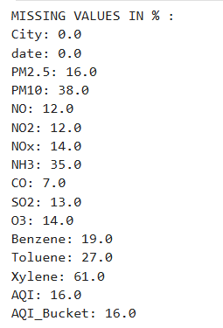
INFERENCE:
Missing Values
No (0%) – City, date
Low (1-5%) - no
Moderate (5-20%) – PM2.5 , NO , NO2, NOX, CO ,SO2 ,O3 , Benzene , AQI , AQI_Bucket
High – Xylene ,Toluene , PM10 , NH3
HANDLING TECHNIQUES:
we can use mean for numeric data and mode is used for categorical data

DETECTING IRREGULAR CARDINALITY
len(df['City'].unique())
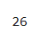
len(df['Date'].unique())
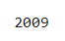
len(df['AQI_Bucket'].unique())
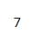
import seaborn as sns
sns.countplot(df['City'])
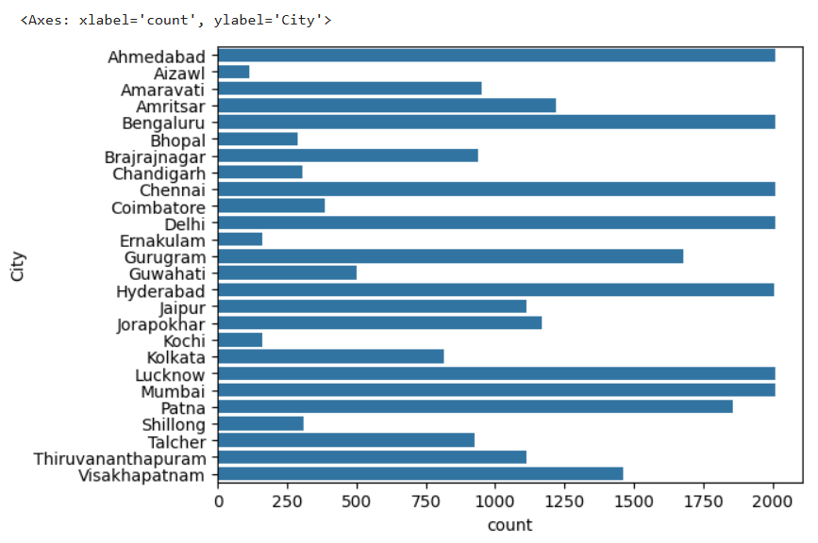
IDENTIFYING OUTLIERS
q1=df['PM10'].quantile(0.25)
q3=df['PM10'].quantile(0.75)
iqr=q3-q1
low=q1-(1.5*iqr)
hi=q3+(1.5*iqr)
print('range : ',df['PM10'].min(),'to',df['PM10'].max())
print('low : ',low)
print('up : ',hi)
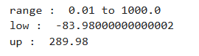
INFERENCE:
values above 290 are considered as outliers
CODE:
zscore = np.abs((df['PM10'] - df['PM10'].mean()) / df['PM10'].std())
df['PM10'][(zscore > 3) | (zscore < -3)]
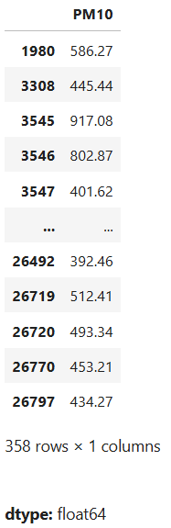

CODE:
sns.boxplot(df['PM10'])
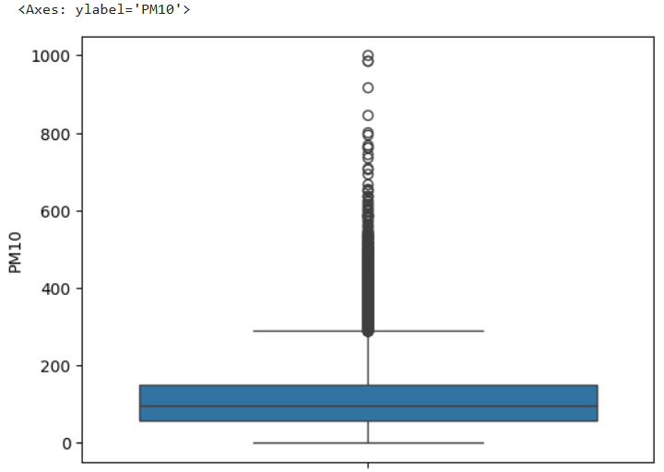
INFERENCE:
There are many outliers in PM10 above 400.

CODE:
import matplotlib.pyplot as plt
plt.scatter(df.index,df['PM10'])
plt.xlabel("PM10")
plt.ylabel("index")
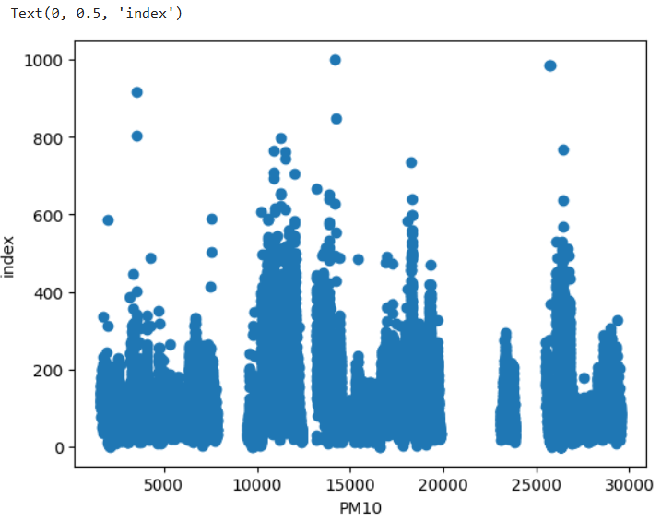
INFERENCE:
There are many outliers in PM10 above 400.

DATA QUALITY REPORT
def report(df):
mi = df.isnull().sum()
mi = (mi / len(df)) * 100
report = pd.DataFrame({
'Feature': mi.index,
'Missing Values': mi.values,
'Percentage': mi.values })
report = report[report['Missing Values'] > 0].sort_values(by='Percentage',ascending=False)
print("Missing Value Report:")
display(report)
return report
def report2(df, threshold=10):
categorical_features = df.select_dtypes(include=['object']).columns
report = {}
for feature in categorical_features:
unique_count = df[feature].nunique()
if unique_count > threshold:
report[feature] = unique_count
print("\nIrregular Cardinality Features (Unique Count > {}):".format(threshold))
for feature, count in report.items():
print(f"- {feature}: {count}")
return report
def report3(df, method='zscore', threshold=3):
numerical_features = df.select_dtypes(include=['number']).columns
report = {}
for feature in numerical_features:
if method == 'zscore':
z_scores = np.abs((df[feature] - df[feature].mean()) / df[feature].std())
outliers = df[z_scores > threshold]
elif method == 'iqr':
Q1 = df[feature].quantile(0.25)
Q3 = df[feature].quantile(0.75)
IQR = Q3 - Q1
lower_bound = Q1 - 1.5 * IQR
upper_bound = Q3 + 1.5 * IQR
outliers = df[(df[feature] < lower_bound) | (df[feature] > upper_bound)]
repor[feature] = len(outliers)
print("\nOutlier Summary ({} Method):".format(method))
for feature, count in report.items():
print(f"- {feature}: {count}")
return report
report(df)
report2(df)
report3(df)
OUTPUT:
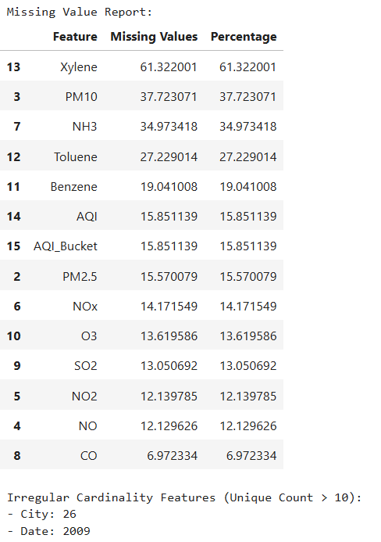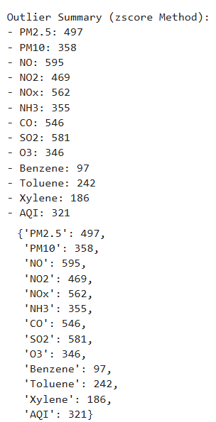

RESULT:
We have Developed a Data Quality Report by programmatically identifying missing values, irregular cardinality, and outliers using Python.
EX. NO: 04  10 .02 .25 | STORYTELLING WITHOUT AND WITH DATA
AIM:
The objective of this laboratory exercise is to explore the power of storytelling in the context of data analytics.

STORYTELLING WITHOUT DATA
In early 2020, the world was shaken by an unknown virus spreading rapidly across countries. People started falling sick, and hospitals became overcrowded. Some thought only the elderly were at risk, while others assumed it was just like the flu. Many struggled to understand how the virus spread, leading to mixed responses from communities worldwide.
After research , they founded it was due to coronavirus disease and they named it as covid 19. It is an infectious disease. Most of the People with respiratory issues affected by it . covid 19 afftects the Indians at the time of march, 2020. People above the age of 70 suffers a lot compared to others.

Since it was infectious, number of people died were increases rigorously(i.e) 3 million people per day globally. To reduce the number of deaths, govt. decided to declare lockdown . During lockdown, daily wages people suffers a lot in terms of their work. Many believed that the virus would disappear within a few months, and life would return to normal soon.
The major symptoms include cold, cough, dry throat, fever, lack of taste, difficulty in breathing.The people who had these symptoms got isolated from others, tried hot water steaming. During lockdown, People were advised to wear mask, clean the hands frequently, avoid physical contact.
Many hospitals faced severe shortages of medical supplies, including oxygen cylinders, ventilators, and critical medicines. Due to a lack of oxygen, thousands of patients struggled to breathe, and many lost their lives. Families searched desperately for oxygen supplies, leading to chaotic situations in hospitals and black markets.


Scenario of people affected by covid:

Scenario of people in lockdown:
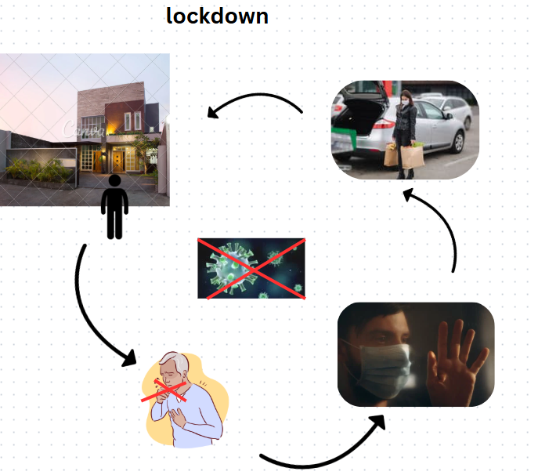

STORY TELLING WITH DATA
CODE:
import pandas as pd
df=pd.read_csv("country_wise_latest.csv")
df.head()
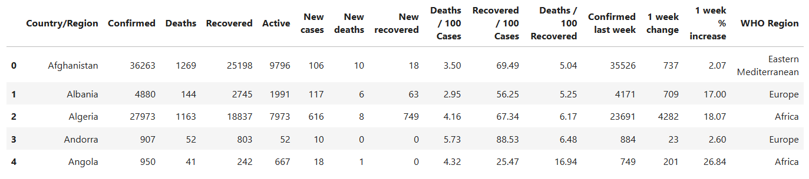
CODE:
import matplotlib.pyplot as plt
import seaborn as sns
plt.figure(figsize=(10,5))
plt.title("Deaths in WHO region")
sns.barplot(x="WHO Region",y="Deaths",data=df)
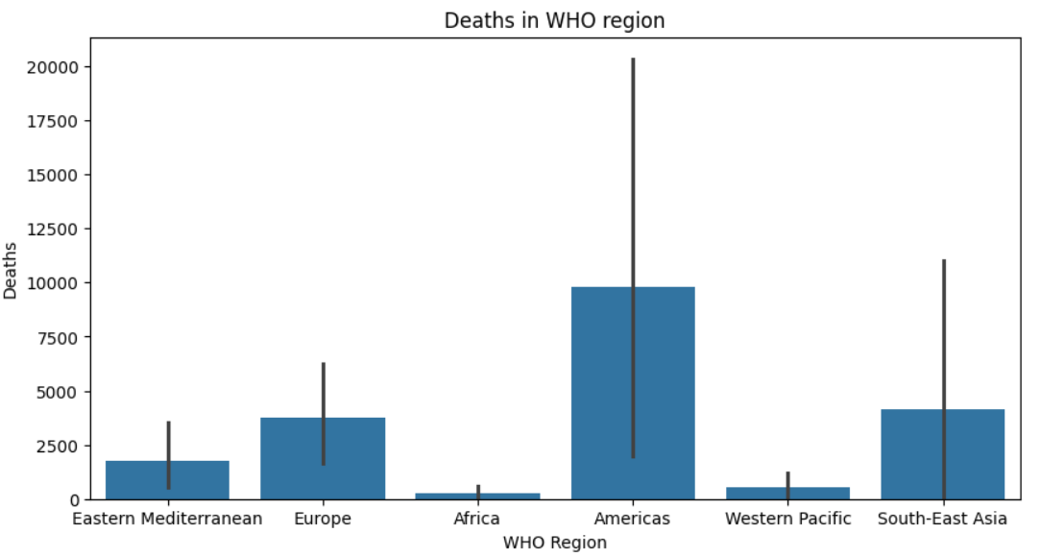
INFERENCE:
Americas is the most affected WHO region in terms of deaths. Africa has the lowest number of deaths with the least uncertainty.

CODE:
sns.lineplot(x='Recovered',y='WHO Region',data=df,hue='WHO Region')
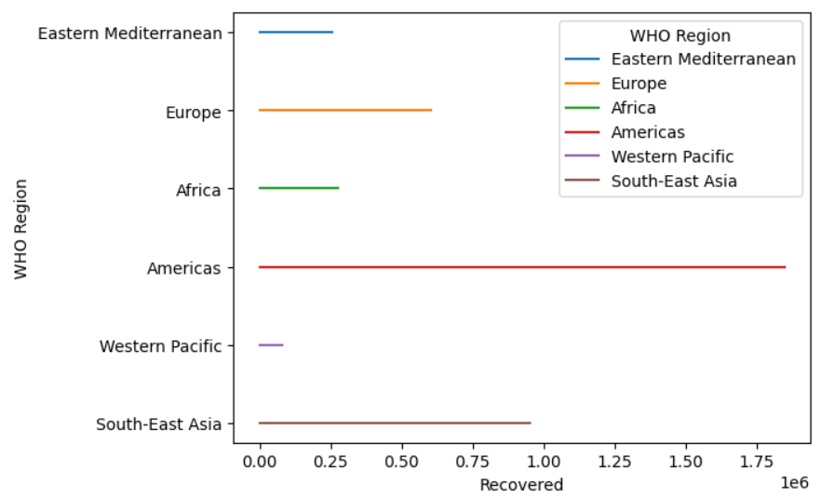
INFERENCE:
Americas has Highest recoveries, but previously seen as also having the highest deaths. South-East Asia has Strong recovery, moderate deaths — possibly effective management.Western Pacific has Lowest recoveries and deaths — could reflect strong containment or fewer cases.
CODE:
import plotly.express as px
fig = px.scatter(df, y="Confirmed", x="Deaths", color="WHO Region",size='Recovered',)
fig.update_layout(title_text="Confirmed, Recovered, and Death Cases Across Regions")
fig.show()
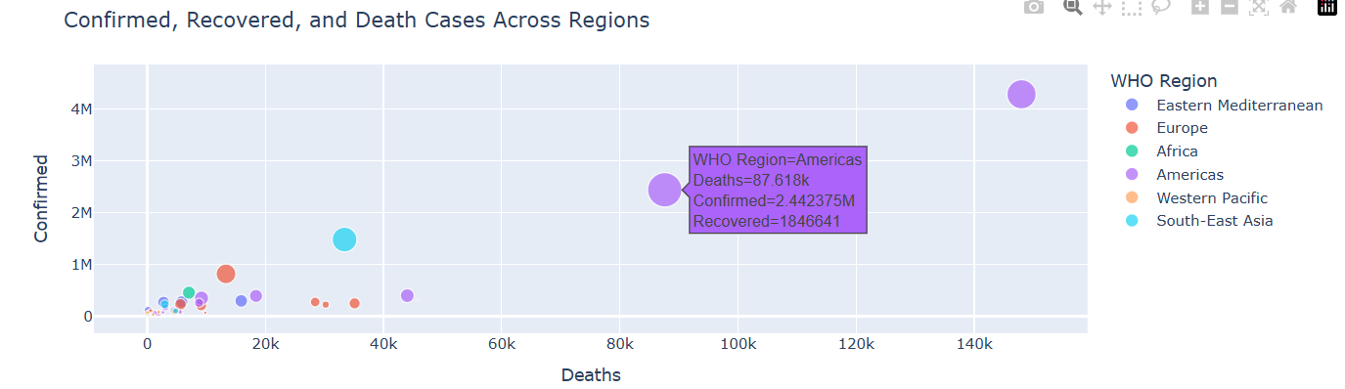
INFERENCE:
The Americas lead in all metrics. Europe and South-East Asia are significantly affected but recovering well. Africa, Eastern Mediterranean, and Western Pacific show lower impact and decent recovery relative to cases.
CODE:
import plotly.graph_objects as go
fig = go.Figure()
fig.add_trace(go.Bar(x=df["WHO Region"],y=df['Confirmed'], name='Confirmed',marker_color='blue'))
fig.add_trace(go.Bar(x=df['WHO Region'],y=df['Recovered'],name='Recovered',marker_color='green'))
fig.add_trace(go.Bar(x=df['WHO Region'],y=df['Deaths'], name='Deaths',marker_color='red'
))
fig.update_layout( title='Cumulative COVID-19 Cases Over Time',xaxis_title='REGIONS', yaxis_title='Number of Cases', barmode='stack', legend_title='Case Type', template='plotly')
fig.show()
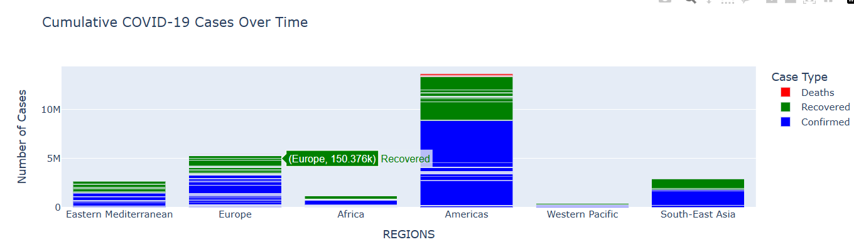
INFERENCE:
Americas is the most affected region in terms of total confirmed and deaths. Europe and South-East Asia show strong recovery numbers. Western Pacific had the most controlled spread. Africa, though lower in confirmed cases, has a promising recovery-to-case ratio.

CODE:
sns.distplot(df["1 week % increase"])
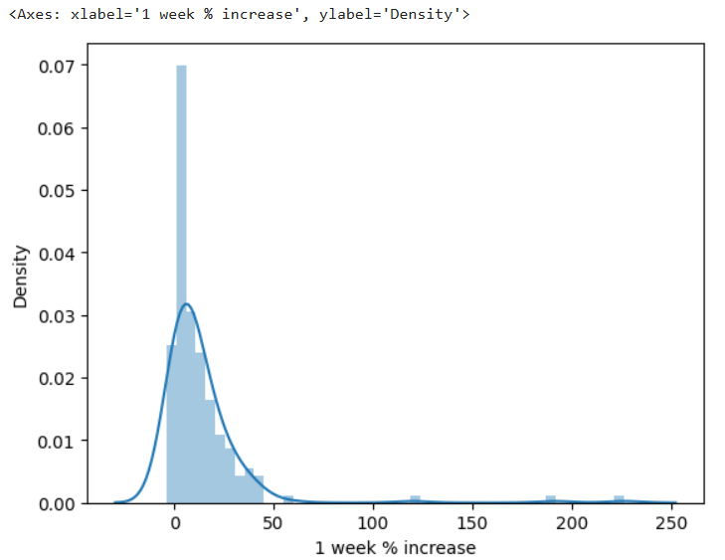
INFERENCE:
The 1-week % increase in cases is not symmetrically distributed. Most regions saw small increases, but a few had sharp spikes. Data indicates potential volatility or sudden outbreaks in a few regions
CODE:
country = 'Afghanistan'
country_data = df[df['Country/Region'] == country].iloc[0]
pie_data = {'Status': ['Active', 'Recovered', 'Deaths'], 'Count': [country_data['Active'], country_data['Recovered'], country_data['Deaths']] }
pie_df = pd.DataFrame(pie_data)
fig = px.pie(pie_df, values='Count', names='Status', title=f'Proportions of COVID-19 Cases ', color='Status', color_discrete_sequence=px.colors.sequential.RdBu)
fig.show()
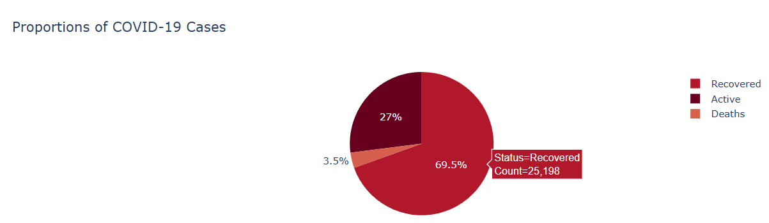
INFERENCE:
Recovered count was very high compared to other two.
CODE:
sns.scatterplot(x='Confirmed',y='Deaths',data=df,hue='WHO Region')
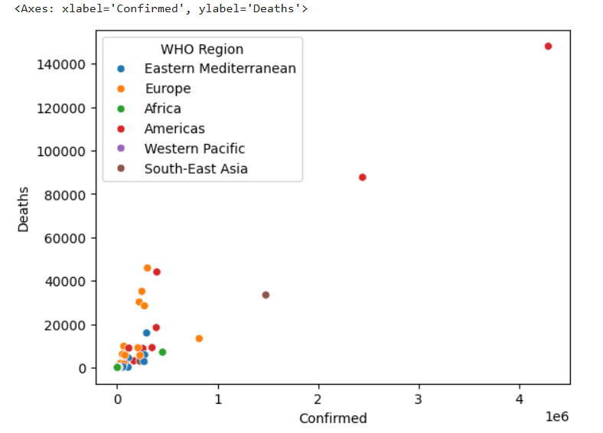
INFERENCE:
Strong correlation between confirmed and death cases. Americas has the most severe impact.Europe and South-East Asia show considerable case and death counts. Africa and Western Pacific regions show relatively low impact, at least based on confirmed data.

RESULT:
We have explored the power of storytelling in the context of data analytics.

EX. NO: 05  18 .02 .25 | ANALYZING PERSONAL EMAIL DATA
AIM:
The objective of this laboratory exercise is to analyse the personal email data

DATA LOADING & CLEANING
import mailbox
import pandas as pd
from email import message_from_string
from email.utils import parsedate_to_datetime
mbox = mailbox.mbox('All mail Including Spam and Trash.mbox')
def contains_photos(message):
if message.is_multipart():
for part in message.walk():
content_type = part.get_content_type()
if content_type.startswith("image"):
return True
return False
def classify_email(subject, sender_email, recipient_email, headers):
subject_lower = subject.lower()
sender_email_lower = sender_email.lower()
recipient_email_lower = recipient_email.lower()
if sender_email_lower == recipient_email_lower:
return "Itself"
elif "trash" in subject_lower or "deleted" in subject_lower or "removed" in subject_lower or "X-Trash" in headers:
return "Trash"
elif "spam" in subject_lower or "free" in subject_lower or "win" in subject_lower:
return "Spam"
elif ".edu" in sender_email_lower or "university" in subject_lower or "exam" in subject_lower or "nptel" in sender_email_lower:
return "University"
elif "offer" in subject_lower or "sale" in subject_lower or "promotion" in subject_lower or "job alerts" in subject_lower:
return "Commercial"
elif "archive" in subject_lower or "archived" in subject_lower:
return "Archived"
else:
return "Other"

def extract_email_content(message):
if message.is_multipart():
for part in message.walk():
if part.get_content_type() == 'text/plain':
return part.get_payload(decode=True).decode(errors='replace')
else:
# Non-multipart emails
return message.get_payload(decode=True).decode(errors='replace')
return "No Content"
def classify_time_of_day(hour):
if 5 <= hour < 12:
return "Morning"
elif 12 <= hour < 17:
return "Afternoon"
elif 17 <= hour < 21:
return "Evening"
else:
return "Night"
emails = []
for message in mbox:
email_message = message_from_string(message.as_string())
subject = email_message['subject'] or "No Subject"
sender = email_message['from'] or "No Sender"
recipient = email_message['to'] or "No Recipient"
date = email_message['date'] or "No Date"
subject = subject.replace('\n', '').replace('\r', '')
sender = sender.replace('\n', '').replace('\r', '')
recipient = recipient.replace('\n', '').replace('\r', '')
if "<" in sender and ">" in sender:
sender_name = sender.split("<")[0].strip()
sender_email = sender.split("<")[1].replace(">", "").strip()
else:
sender_name = sender
sender_email = "Unknown"
if "<" in recipient and ">" in recipient:
recipient_email = recipient.split("<")[1].replace(">", "").strip()
else:
recipient_email = recipient
content = extract_email_content(email_message)
has_photos = "Yes" if contains_photos(email_message) else "No"
category = classify_email(subject, sender_email, recipient_email, {})
parsed_date = parsedate_to_datetime(date)
email_date = parsed_date.date()
email_time = parsed_date.time()
day_of_week = parsed_date.strftime("%A")
is_weekend = "Weekend" if day_of_week in ["Saturday", "Sunday"] else "Weekday"
time_of_day = classify_time_of_day(parsed_date.hour)
emails.append({ 'Sender Name': sender_name, 'Sender Email': sender_email,'Recipient Email': recipient_email, 'Subject': subject, 'Date': email_date, 'Time': email_time, 'Day of Week': day_of_week, 'Weekday/Weekend': is_weekend, 'Time of Day': time_of_day, 'Has Photos': has_photos, 'Content': content, 'Category': category, })
df = pd.DataFrame(emails)
df.head()
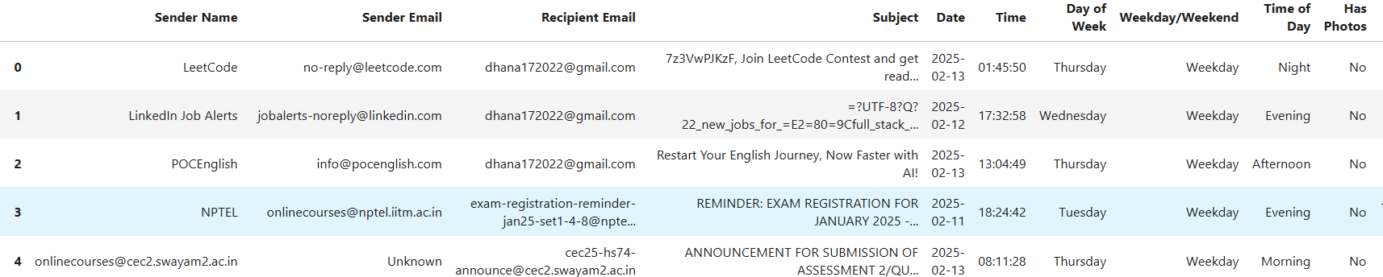
CODE:
mno.bar(df)
OUTPUT:
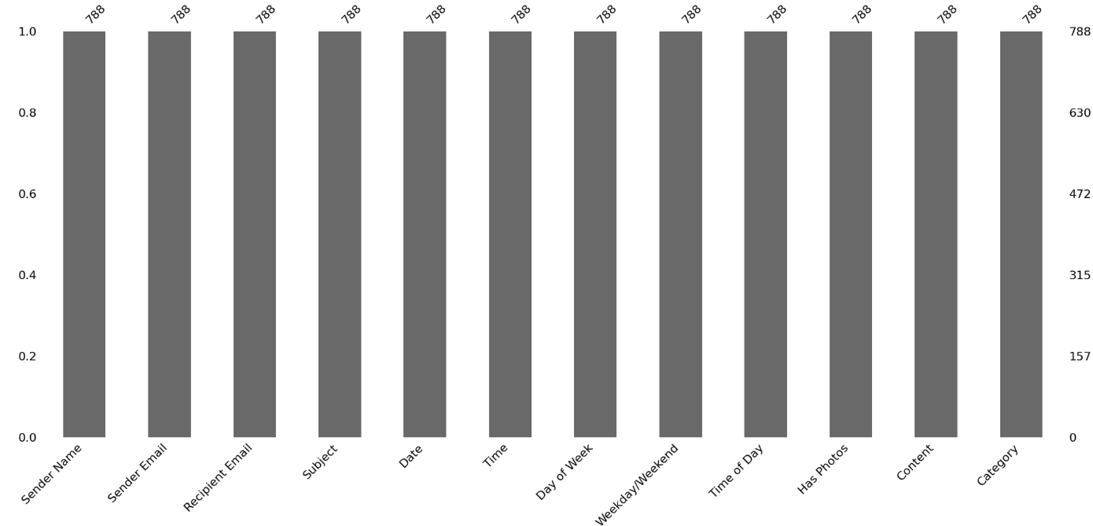
INFERENCE:
There is no missing values
EDA
s=(df['Sender Email']=='dhana172022@gmail.com').sum()
r=(df['Recipient Email']=='dhana172022@gmail.com').sum()
print("number of mails sent : ",s)
print("number of mails received : ",r)
OUTPUT:
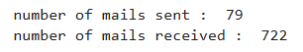
CODE:
import seaborn as sns
df['Sender Email'].value_counts().head(10)
OUTPUT:
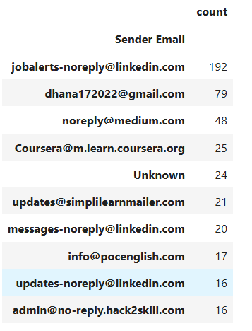
CODE:
d1=df['Recipient Email'].groupby(df['Date']).size()
print('the average number of emails received per day : ',d1.mean())
OUTPUT:
CODE:
edf = df[['Recipient Email', 'Date']].copy()
edf['ISO Week'] = edf['Date'].dt.isocalendar().week
w = edf.groupby('ISO Week').size()
print('the average number of emails received per week : ',w.mean())
OUTPUT:
CODE:
df['Subject Length'] = df['Subject'].str.len()
sns.distplot(df['Subject Length'])
plt.title('Distribution of Subject Length')
plt.xlabel('Subject Length')
plt.ylabel('Frequency')
plt.show()
OUTPUT:
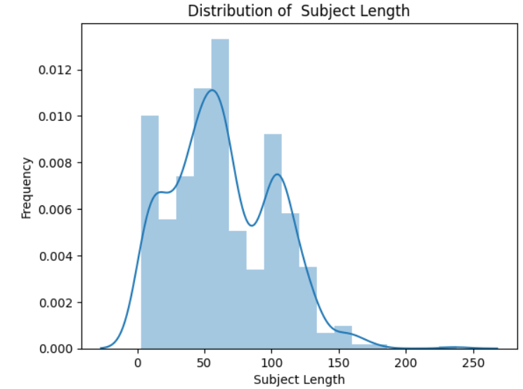
INFERENCE:
Most subjects are between 30 to 100 characters long. The most common subject length is around 50–60 characters. A few subjects are very long, above 150 characters, but they are rare.

VISUALIZATION TASKS
top=df['Sender Name'].value_counts().head(10)
plt.figure(figsize=(15,3))
plt.bar(top.index,top.values, width=0.5)
plt.xlabel('Sender Email')
plt.ylabel('Number of Emails')
plt.title('Top 10 Email Senders')
plt.xticks(rotation=45)
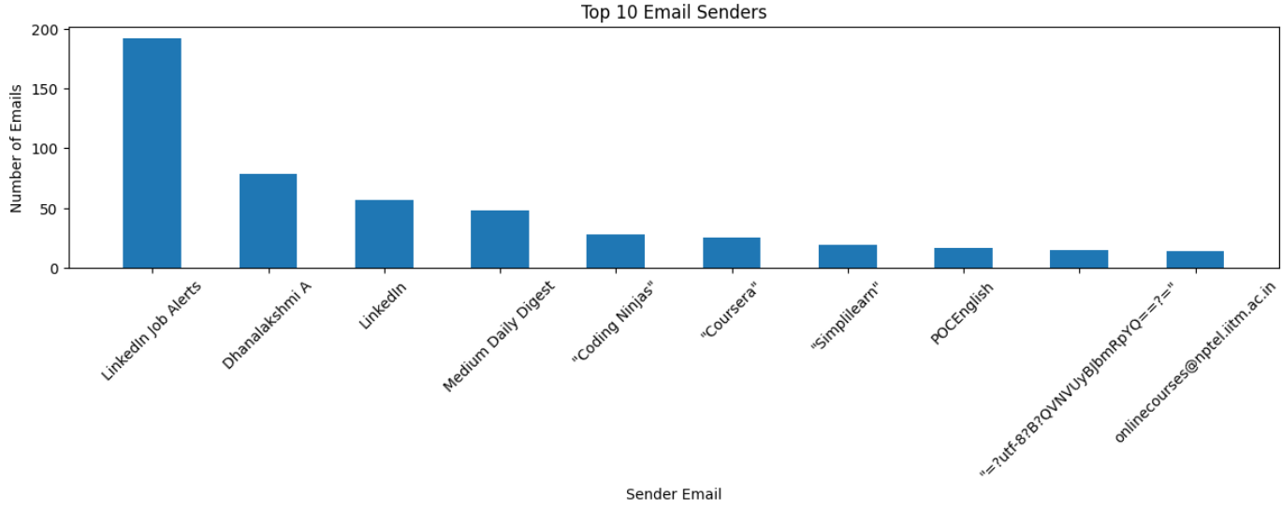
INFERENCE:
Number of email send by linkedin is high.
CODE:
t = df.groupby('Date').size();
plt.plot(t.index, t.values)
plt.xlabel('Date')
plt.ylabel('Email Volume')
plt.title('Time-Series ')
plt.show()
OUTPUT:
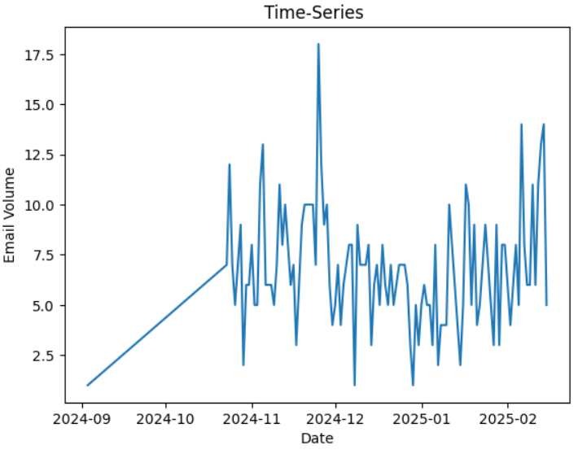
INFERENCE:
Email volume increased steadily from September to November 2024. After November, the volume becomes more irregular, with frequent ups and downs. There’s a sharp peak in December 2024, indicating the highest email activity.

MOST COMMON WORDS
from collections import Counter
import re
from wordcloud import WordCloud, STOPWORDS
text = " ".join(subject for subject in df.Subject)
words = text.lower().split()
words = [re.sub(r'[^\w\s]', '', word) for word in words]
words = [word for word in words if word]
w = Counter(words)
w = w.most_common(100)
wor = WordCloud(width=800, height=400, background_color="white", stopwords=STOPWORDS).generate_from_frequencies(dict(most_common_words))
plt.figure(figsize=(5, 5))
plt.imshow(wordcloud, interpolation="bilinear")
plt.axis("off")
plt.title(f"Word Cloud of {N} Most Common Words in Email Subjects")

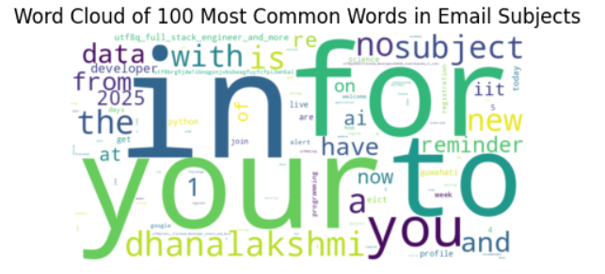

CODE:
df['Time'] = pd.to_datetime(df['Time'], format='%H:%M:%S').dt.time
df['Hour'] = pd.to_datetime(df['Time'], format='%H:%M:%S').dt.hour
email_activity = df.pivot_table(index='Day of Week', columns='Hour', values='Subject', aggfunc='count', fill_value=0)
days_order = ['Monday', 'Tuesday', 'Wednesday', 'Thursday', 'Friday', 'Saturday', 'Sunday']
email_activity = email_activity.reindex(days_order)
plt.figure(figsize=(12, 6))
sns.heatmap(email_activity)
plt.title('Email Activity Heatmap by Day of Week and Hour')
plt.xlabel('Hour of Day')
plt.ylabel('Day of Week')
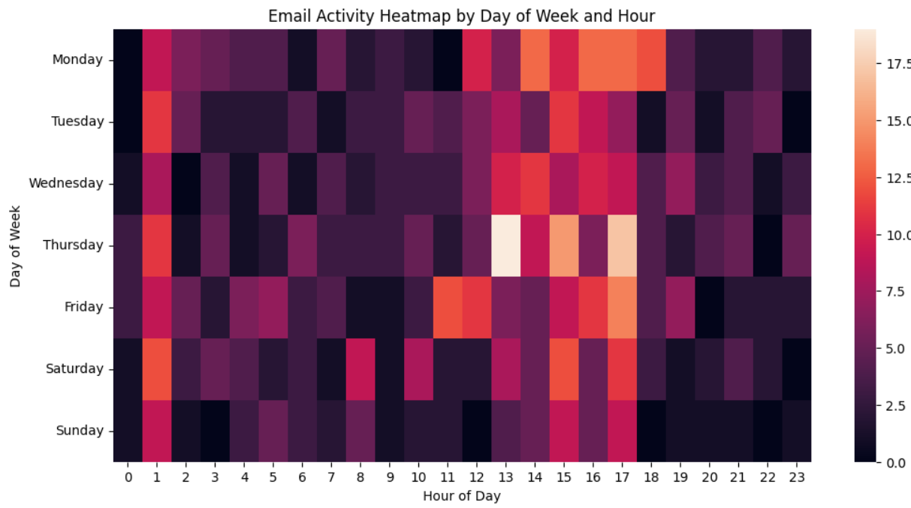

RESULT:
We have analysed the personal email.
EX. NO: 06  03 .03 .25 | INSTALLATIONS AND THE STEPS FOR PACKAGES
AIM:
The objective of this laboratory exercise is to Perform the installation of the following tools and libraries: Python, NumPy, SciPy, Jupyter, Statsmodels, and Pandas.

INSTALLATION OF PYTHON
Download python in browser. After that perform the following
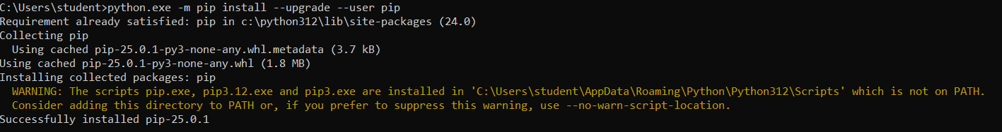
Sample python program in command prompt:
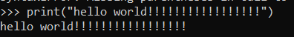

INSTALLATION OF NUMPY
pip install numpy
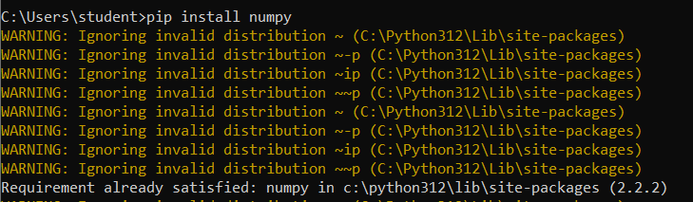

Sample code:
import numpy as np
b=np.array(range(1,20))
print("array",b)
print("shape:",np.shape(b))
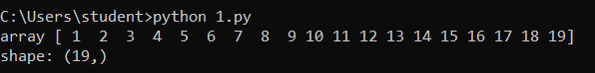

INSTALLATION OF PANDAS
pip install pandas
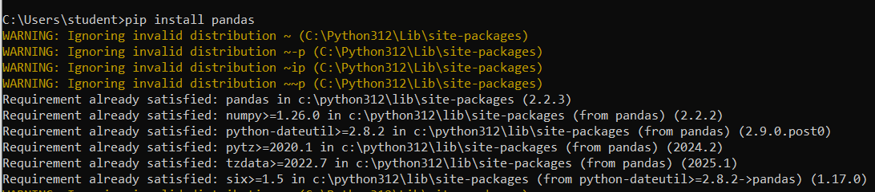
Sample code :
import pandas as pd
df=pd.read_csv(r"C:\Users\student\Desktop\Iris.csv")
print(df.head())
print("shape:",df.shape)
print("checking null values:\n",df.isnull())
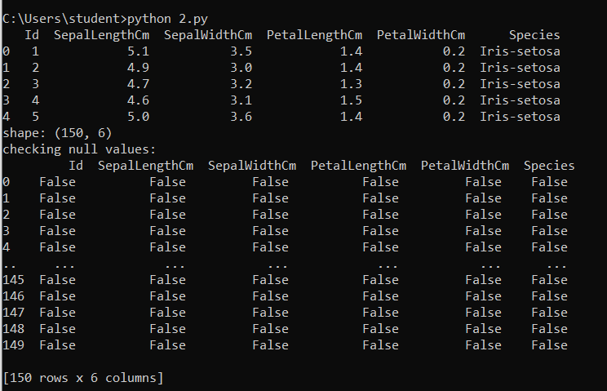

INSTALLATION OF SCIPY
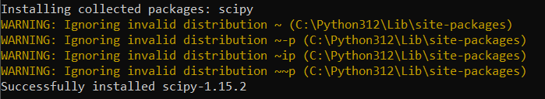
Sample code
from scipy.special import factorial
n=16
s=factorial(16)
print("factorial of ",n," is ",s)
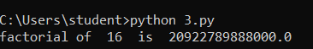

INSTALLATION OF STATSMODEL
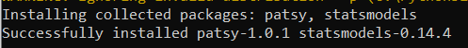
Sample code :
import statsmodels.api as sm
d = [10, 100, 20, 49, 50]
desc = sm.stats.DescrStatsW(d)
print("data:",d)
print("mean : ",desc.mean)
print("median : ",desc.std)
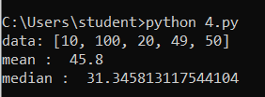

INSTALLATION OF JUPYTER NOTEBOOK
pip install --user notebook
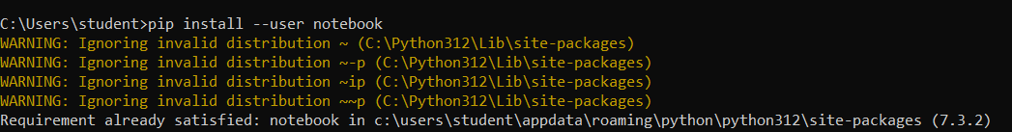
JUPYTER NOTEBOOK-LOCALHOST:
OPTION 1
i)Finding installation path and adding jupyter to path
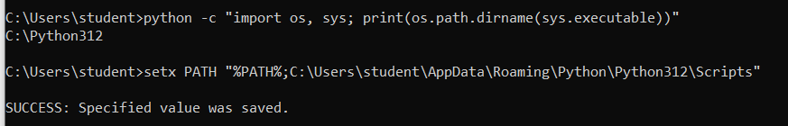
ii)restart cmd
iii)jupyter notebook
jupyter notebook –local host opens in brower

OPTION 2
python -m notebook run this in cmd for opening jupyter notebook in local host

RESULT:
we have Performed the installation of the following tools and libraries: Python, NumPy, SciPy, Jupyter, Statsmodels, and Pandas.
EX. NO: 07  10 .03 .25 | FEATURE IDENTIFICATION FOR TARGET PREDICTION
AIM:
To identify important descriptive features for predicting a target feature by analyzing and visualizing relationships between variables in a dataset.

LOAD AND EXPLORE THE DATASET
import pandas as pd
df=pd.read_csv(r"C:\Users\hanal\Downloads\diabetes.csv")
df.head()
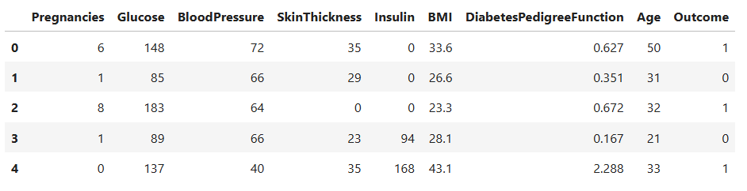
df.info()
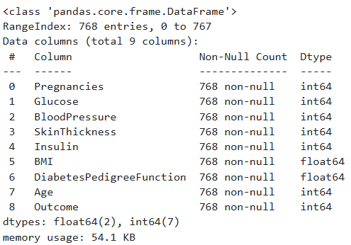
df.describe()
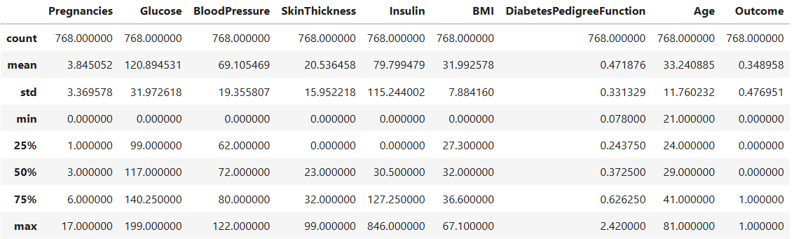
PREPROCESS DATA
import missingno as mn
mn.bar(df)
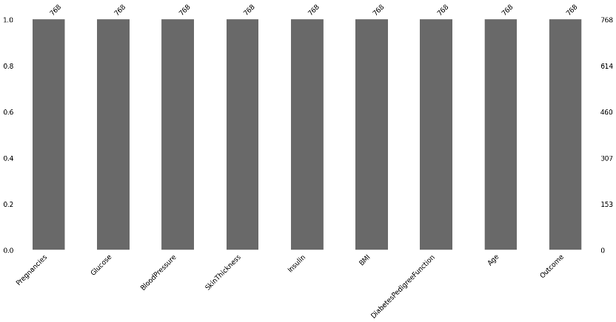
INFERENCE: there are no missing values

VISUALIZE FEATURE RELATIONSHIPS
import seaborn as sns
sns.pairplot(df,hue='Outcome')
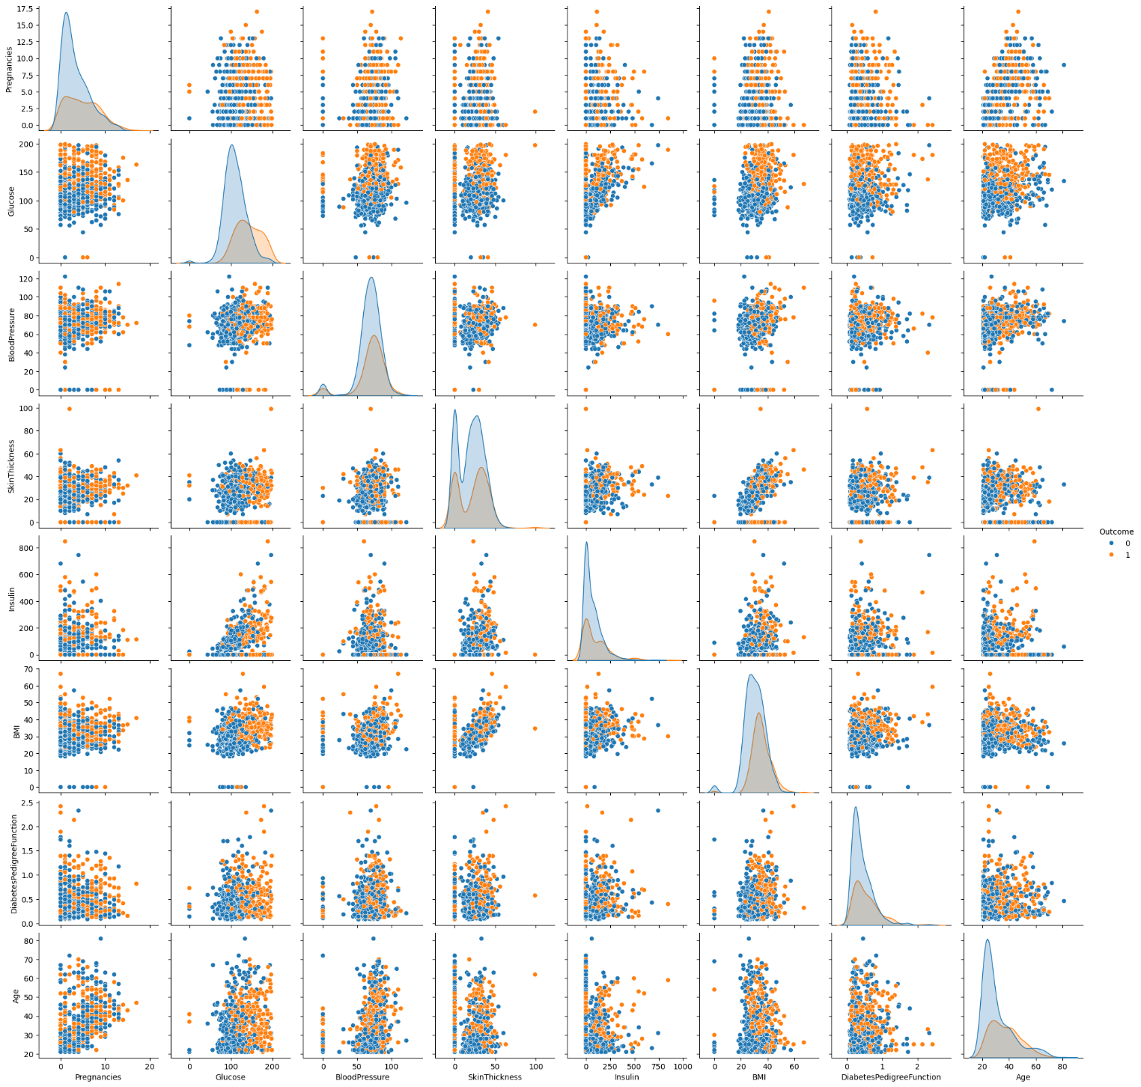

INFERENCE:
Features like Glucose, BMI, and Age are more effective at separating diabetic vs non-diabetic classes. Some features like BloodPressure and DiabetesPedigreeFunction have limited separation and would be more useful when used in combination with other features

CODE:
sns.heatmap(df.corr())
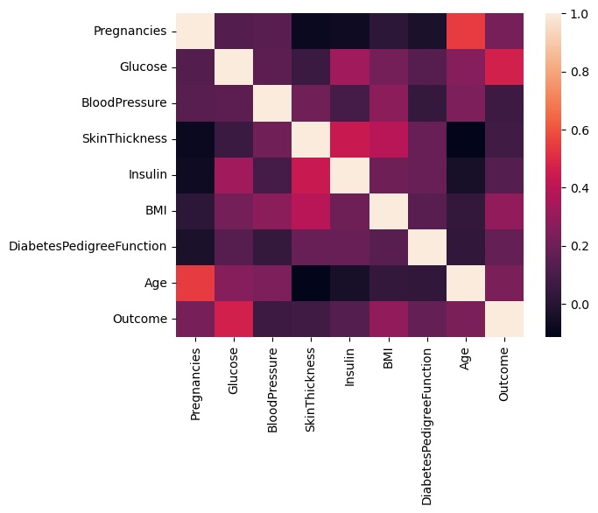
INFERENCE:
Glucose is the most important single predictor. BMI, Age, and Pregnancies are also useful. Features like BloodPressure and SkinThickness are less helpful on their own but may still contribute in combinations

CODE:
sns.boxplot(x='Outcome', y='Age', data=df)
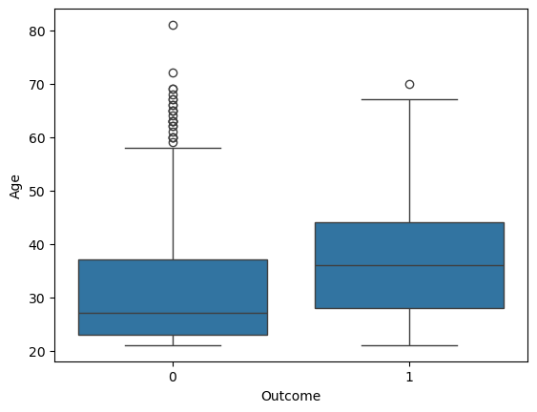
INFERENCE:
There are many outliers in outcome 0.
CODE:
bins = [0, 30, 50, df['Age'].max()]
labels = ['Young ', 'Middle', 'Older']
df['Age_Group'] = pd.cut(df['Age'], bins=bins, labels=labels, include_lowest=True)
sns.countplot(data=df,x='Age_Group',hue='Outcome')
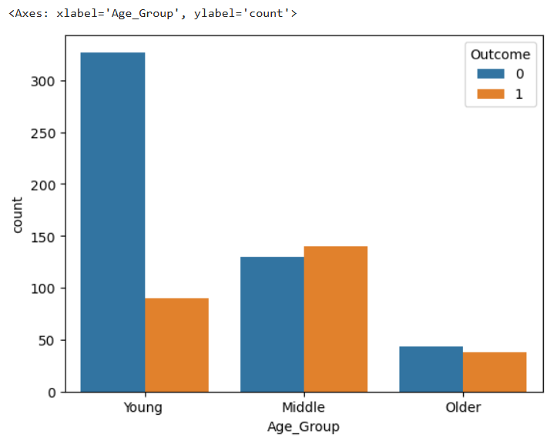
INFERENCE:
Young (age group – 0 to 30) peoples have higher outcome 0 count.
INTERPRET RESULTS
strong influence on target:
Glucose : Higher glucose levels strongly indicate diabetes.
BMI : Higher BMI is associated with increased diabetes risk.
Age : Older individuals are at higher risk.
middle age of diabetic patients (Outcome = 1) is higher than non-diabetic individuals.
potential features:
age
glucose
BMI
pregnancies
Diabetes pedigree function

RESULT:
We have identified important descriptive features for predicting a target feature by analyzing and visualizing relationships between variables in a dataset.

EX. NO: 08  17 .03 .25 | IDENTIFYING AND UNDERSTANDING GROUPS, BUILDING MODELS FROM DATA
AIM:
To analyze a dataset, identify groups/clusters within the data, and build a machine learning model.

LOAD THE DATA
import pandas as pd
df=pd.read_csv(r'C:\Users\student\Desktop\iris.csv')
df.head()
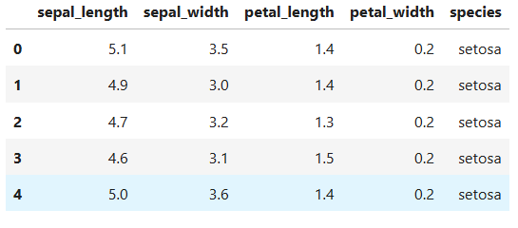

Preprocess the Data:
import missingno as mn
mn.bar(df)
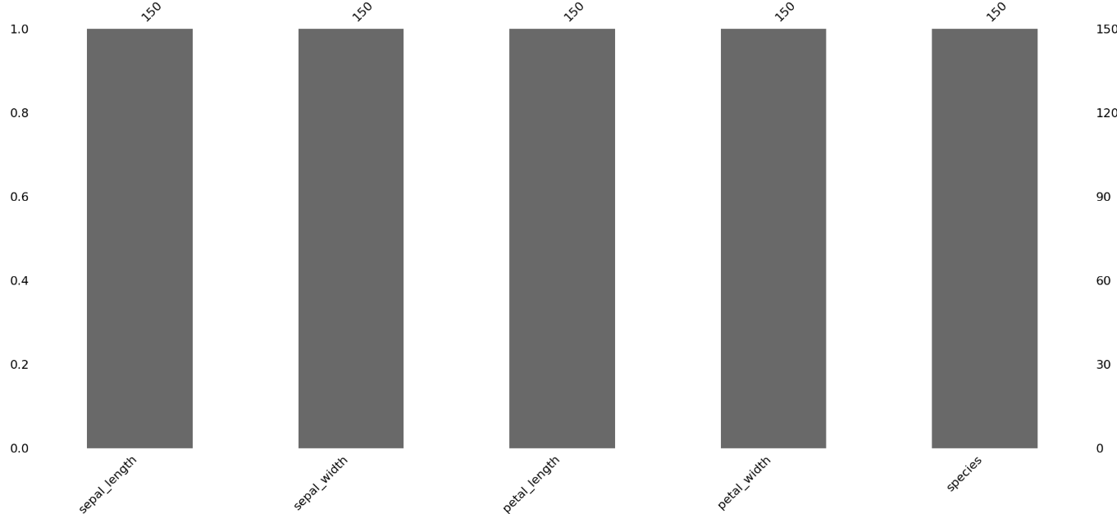

CODE
df.info()
OUTPUT
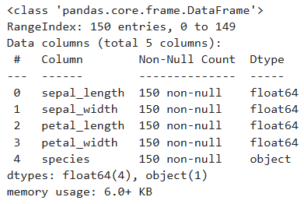

NORMALIZE
from sklearn.preprocessing import StandardScaler as sc
s=sc()
df['sepal_length']=s.fit_transform(df[['sepal_length']])
df['petal_length']=s.fit_transform(df[['petal_length']])
df['sepal_width']=s.fit_transform(df[['sepal_width']])
df['petal_width']=s.fit_transform(df[['petal_width']])

PERFORM EDA:
import seaborn as sns
sns.histplot(df['sepal_width'])
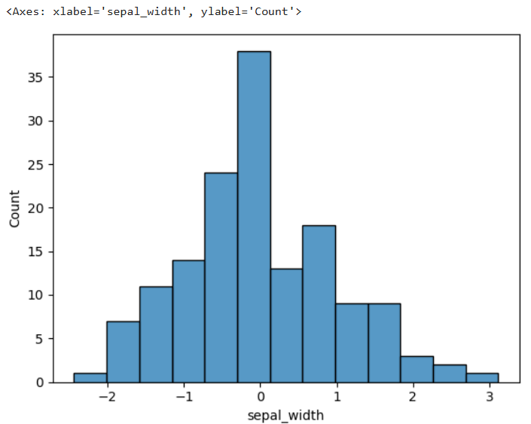
INFERENCE:
sepal_width feature is approximately normally distributed, especially after preprocessing
CODE:
sns.histplot(df['petal_width'])
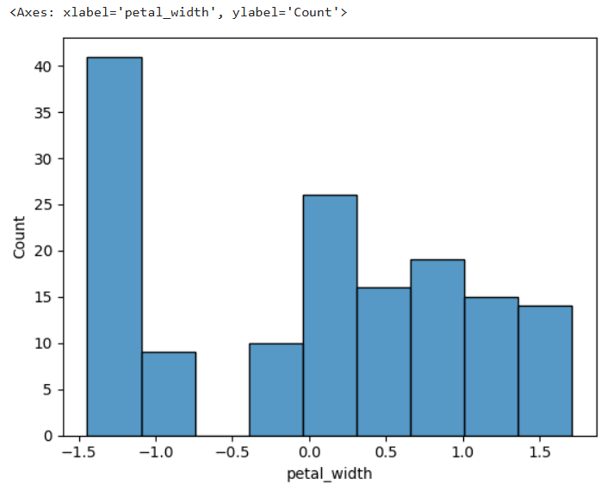
INFERENCE:
petal_width is not normally distributed but bimodal. This is a strong indicator that it may be a good feature for classification, as it clearly separates groups.
CODE:
sns.boxplot(x=df['sepal_length'])
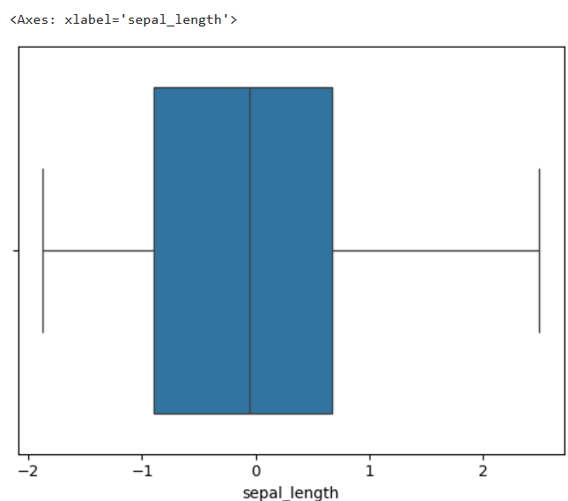
INFERENCE:
Distribution is symmetric and has no outliers, making it suitable for many ML algorithms.
CODE:
sns.boxplot(x=df['petal_length'])
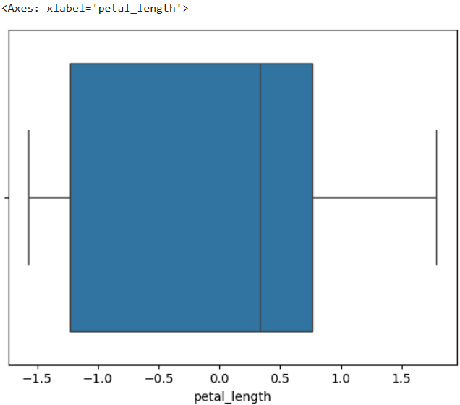
INFERENCE:
petal_length shows a mild positive skew but is well-distributed overall.

CODE:
d=df.iloc[:,:-1]
sns.heatmap(d.corr(),annot=True)
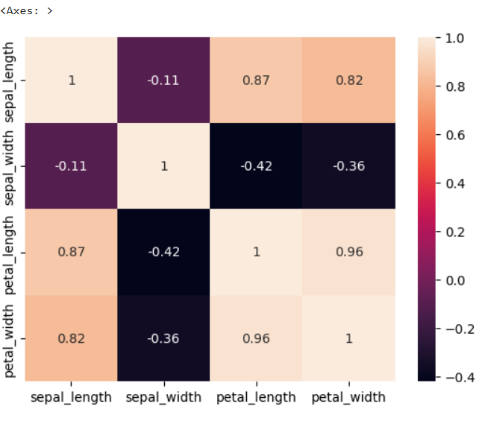
INFERENCE:
The petal-based features (petal_length, petal_width) are highly correlated with each other and with sepal_length, suggesting they capture similar patterns — useful for classification tasks like species identification

K MEANS CLUSTERING
import matplotlib.pyplot as plt
import numpy as np
from sklearn.cluster import KMeans
k=KMeans(n_clusters=3)
yp=k.fit_predict(x)
x_array = x.to_numpy()
plt.scatter(x_array[yp == 0, 0], x_array[yp == 0, 1], s=100, c='blue', label='Cluster 1')
plt.scatter(x_array[yp == 1, 0], x_array[yp == 1, 1], s=100, c='green', label='Cluster 2')
plt.scatter(x_array[yp == 2, 0], x_array[yp == 2, 1], s=100, c='red', label='Cluster 3')
plt.scatter(k.cluster_centers_[:, 0], k.cluster_centers_[:, 1], s=300, c='yellow', marker='X', edgecolors='black', label='Centroids')
plt.xlabel('Feature 1')
plt.ylabel('Feature 2')
plt.legend()
plt.title('K-Means Clustering')
plt.show()
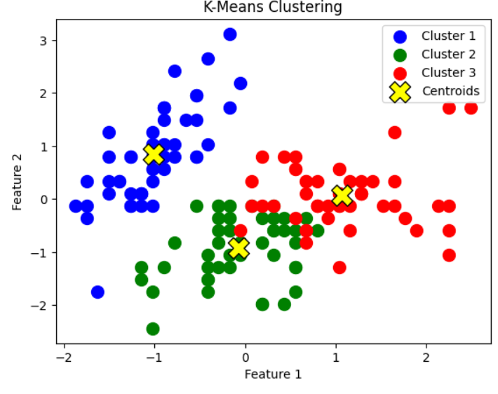
INFERENCE:
The data naturally forms 3 different patterns or categories and kmeans worked well.
BUILD A MODEL
from sklearn.ensemble import RandomForestClassifier as rf
from sklearn.model_selection import train_test_split as tt
from sklearn.metrics import accuracy_score as ac
x=df.iloc[:,:-1]
y=df.iloc[:,-1]
r=rf()
xtrain,xtest,ytrain,ytest=tt(x,y,test_size=20)
r.fit(xtrain,ytrain)
p=r.predict(xtest)
a=ac(ytest,p)
print('ACCURACY SCORE: ',a)
from sklearn.metrics import precision_score as pr
ps = pr(ytest, p, average='macro')
print('PRECISION: ',ps)
from sklearn.metrics import recall_score as re
recall = re(ytest, p,average='macro')
print('RECALL : ',recall)
OUTPUT:
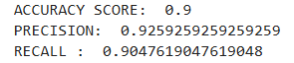

RESULT:
We have analyzed a dataset, identify groups/clusters within the data, and build a machine learning model.

EX. NO: 09  25 .03 .25 | DATA AND CLUSTER ANALYSIS ON HAPPINESS & E-COMMERCE
AIM:
To perform Data and Cluster Analysis on Happiness & E-Commerce

Univariate, Bivariate, and Multivariate Analysis on World Happiness Report
import pandas as pd
df= pd.read_csv(r"C:\Users\student\Downloads\World Happiness Report.csv")
df.head()
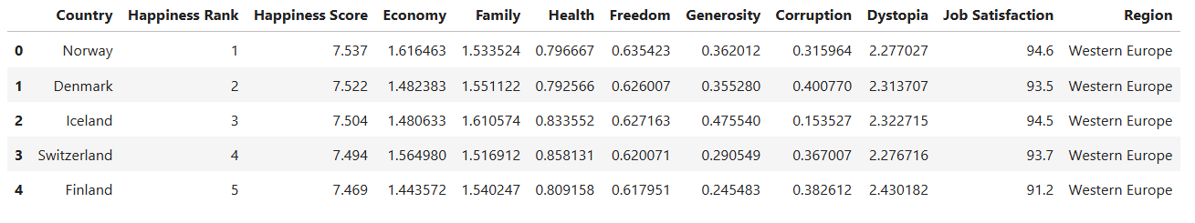
UNIVARIATE ANALYSIS:
import seaborn as sns
sns.histplot(data=df,x='Happiness Score')
sns.boxplot(data=df,x='Happiness Score')
sns.kdeplot(data=df,x='Happiness Score')
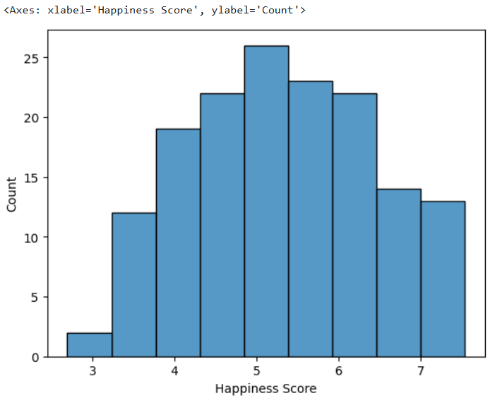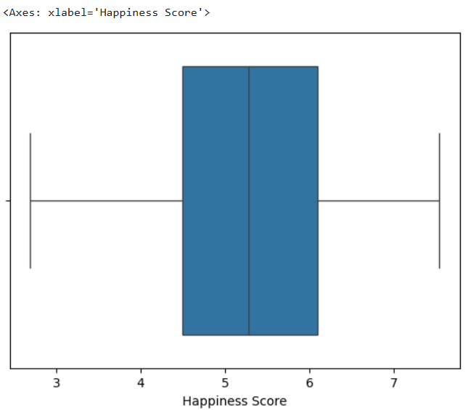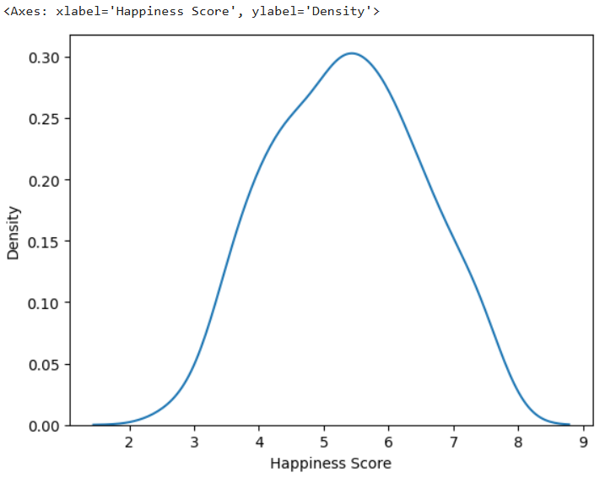
INFERENCE:
Happiness scores are normally distributed (like a bell curve).There’s a good balance, with few very low or very high scores.

CODE:
sns.histplot(data=df,x='Economy')
sns.boxplot(data=df,x='Economy')
sns.kdeplot(data=df,x='Economy')
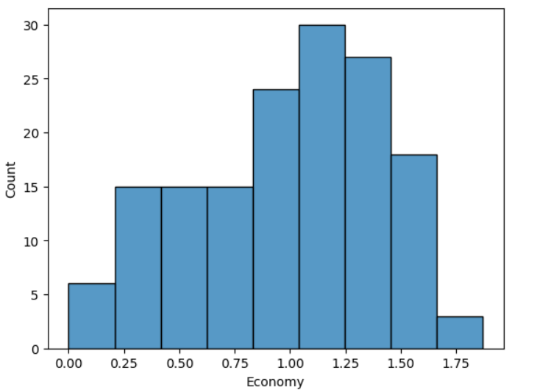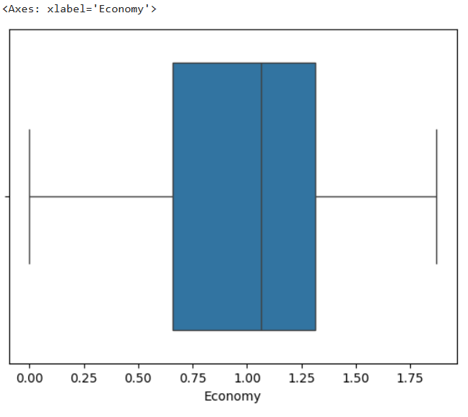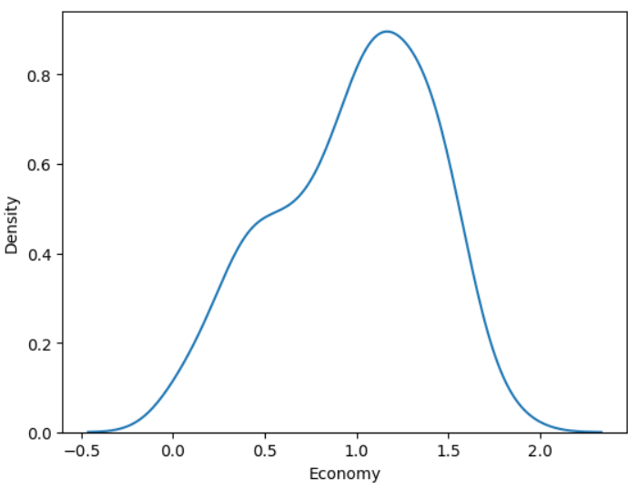
INFERENCE:
Economy scores are fairly balanced, but slightly more countries have higher scores. Most economy scores are around 1.0.
CODE:
sns.histplot(data=df,x='Freedom')
sns.boxplot(data=df,x='Freedom')
sns.kdeplot(data=df,x='Freedom')
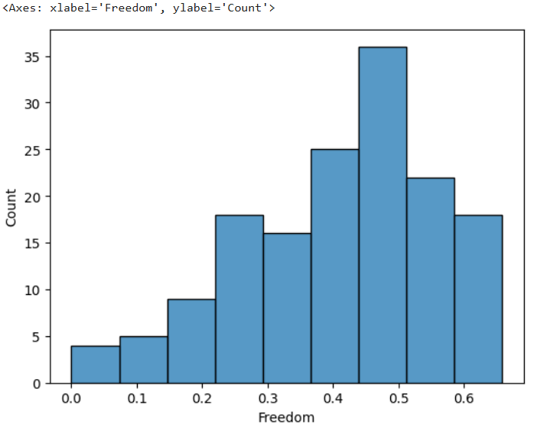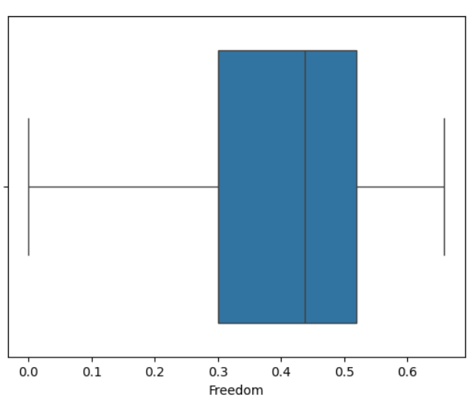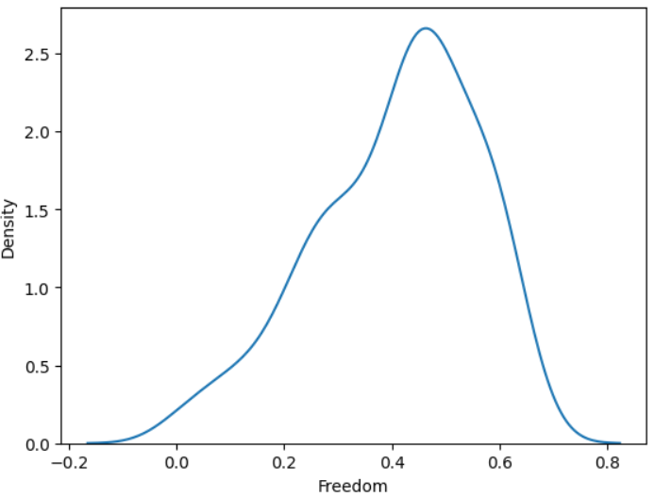
INFERENCE:
Most countries have a moderate level of freedom (around 0.4–0.5). Very low or very high freedom scores are less common

SUMMARY STATISTICS:
m=df.mean(numeric_only=True)
mm=df.median(numeric_only=True)
v=df.var(numeric_only=True)
k=df.kurtosis(numeric_only=True)
s=df.skew(numeric_only=True)
d= pd.DataFrame({ 'MEAN':m, 'MEDIAN':mm, 'VARIANCE':v, 'KURTOSIS':k, 'SKEWNESS':s})
d
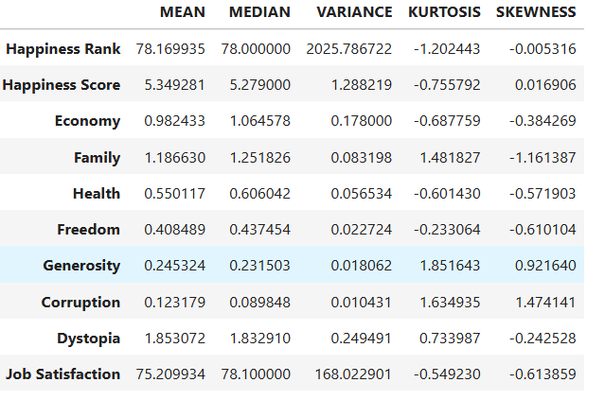
BIVARIANT ANALYSIS
sns.scatterplot(data=df,x='Happiness Score',y='Economy')
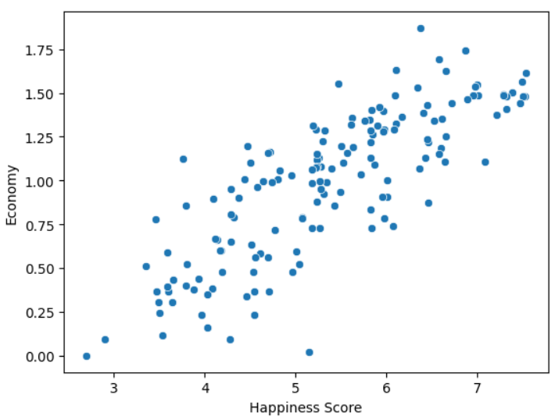

INFERENCE:
Happiness and economy have high positive correlation.
CODE:
ss=["Family","Freedom","Economy","Happiness Score"]
sns.heatmap(df[ss].corr(),annot=True)
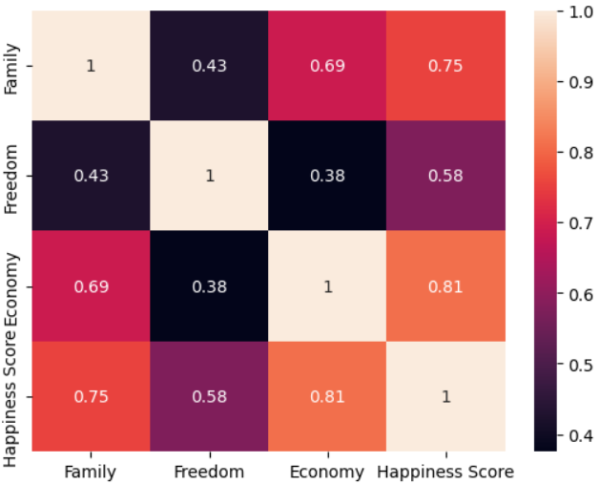
INFERENCE:
Economy, Family, and Freedom all contribute to Happiness, with Economy being the most important factor in this data.

CODE:
df = df[df['Region'] != 'Europe']
fig, ax = plt.subplots(figsize =(9, 7))
sns.violinplot(ax = ax, x = df["Happiness Score"], y = df["Region"] )

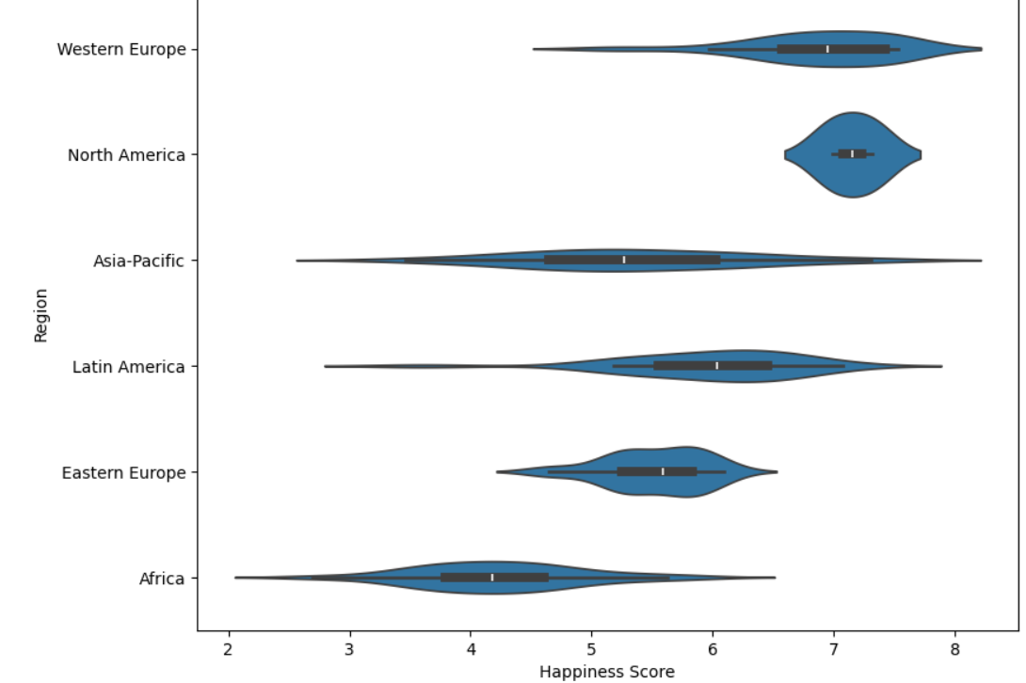
INFERENCE:
Happiness is highest in developed regions (like Western Europe & North America). Africa and parts of Asia tend to have lower happiness scores.There's more variation in regions like Latin America and Asia-Pacific.

MULTIVARIANT
sns.pairplot(df[ss])
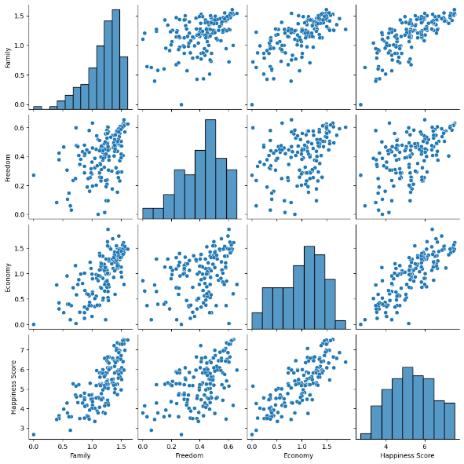
INFERENCE:
When Family, Economy, and Freedom go up, Happiness Score also goes up. The strongest link is between Economy and Happiness. All variables are positively related.

CODE:
import plotly.graph_objects as go
import numpy as np
import pandas as pd
z = df["Happiness Score"].tolist()
x = df["Economy"].tolist()
y = df["Freedom"].tolist()
fig = go.Figure(data=[go.Mesh3d( x=x, y=y, z=z, color="red" )])
fig.show()
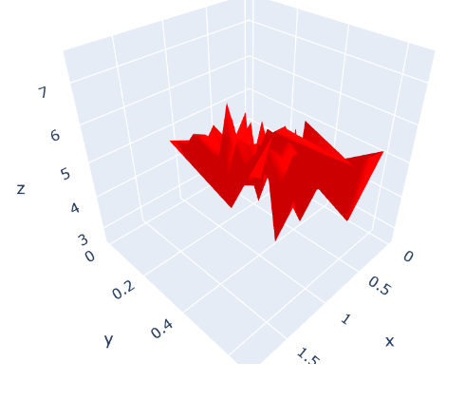
INFERENCE:
The surface is bumpy, meaning the data has ups and downs. Red color highlights the surface

SIMPLE LINEAR REGRESSION
x1=df[['Economy']]
y=df['Happiness Score']
xtr,xte,ytr,yte=tt(x1,y,test_size=0.2)
l=ln()
l.fit(xtr,ytr)
yp=l.predict(xte)
m=mse(yte,yp)
rr=r(yte,yp)
print('MSE : ',m)
print('R2 SCORE : ',rr)
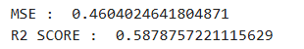
MULTI LINEAR REGRESSION
x2 = df[['Economy', 'Freedom']]
y=df['Happiness Score']
from sklearn.linear_model import LinearRegression as ln
from sklearn.model_selection import train_test_split as tt
from sklearn.metrics import mean_squared_error as mse,r2_score as r
xtr,xte,ytr,yte=tt(x,y,test_size=0.2)
l=ln()
l.fit(xtr,ytr)
yp=l.predict(xte)
m=mse(yte,yp)
rr=r(yte,yp)
print('MSE : ',m)
print('R2 SCORE : ',rr)
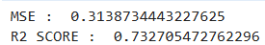

Cluster Analysis & Dynamic Techniques on E-Commerce Dataset

CODE:
df1=pd.read_csv(r"C:\Users\hanal\Desktop\E-commerce Customer Behavior - Sheet1.csv")
df1.head()
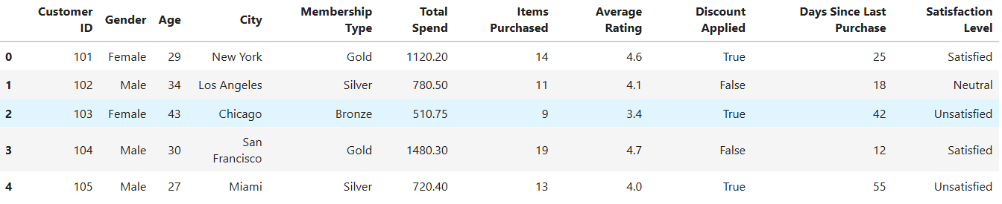

K-Means Clustering:
from kneed import KneeLocator
import numpy as np
import matplotlib.pyplot as plt
import pandas as pd
import sklearn
from sklearn.cluster import KMeans
x=df1[['Age','Total Spend','Items Purchased']]
wcss = []
for i in range(1, 11):
kmeans = KMeans(n_clusters = i, init = 'k-means++', random_state = 42)
kmeans.fit(x)
wcss.append(kmeans.inertia_)
knee_locator = KneeLocator(range(1, 11), wcss, curve="convex", direction="decreasing")
k = knee_locator.elbow
plt.plot(range(1, 11), wcss, marker='o', linestyle='--', color='b', label="WCSS")
plt.axvline(k, color='r', label=f'Elbow at K={optimal_k}')
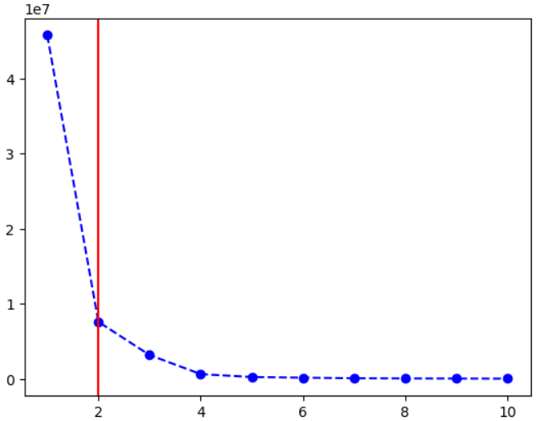
INFERENCE:
From above , we can infer that k=2.

2D
km=KMeans(n_clusters=k)
x['clus']=km.fit_predict(x)
cen=km.cluster_centers_
for i in range(k):
cluster=x[x['clus']==i]
plt.scatter(cluster['Age'],cluster['Total Spend'])
plt.scatter(cen[:,0],cen[:,1],marker='X',s=200,color='green', label='Centroids')
plt.xlabel("Age")
plt.ylabel("Total spend")
plt.title("K - Means Clustering")
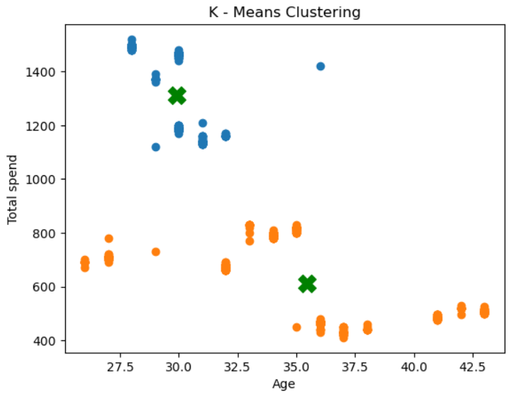
INFERENCE:
younger customers tend to spend more, while older customers are more conservative spenders.

3D
f=plt.figure(figsize=(10,8))
ax=f.add_subplot(111,projection='3d')
for i in range(k):
cluster=x[x['clus']==i]
ax.scatter(cluster['Age'],cluster['Total Spend'],cluster['Items Purchased'],label=f'cluster{i}')
ax.scatter(cen[:,0],cen[:,1],cen[:,2],marker='X',s=200,color='green', label='Centroids')
ax.set_xlabel('Age')
ax.set_ylabel('Total spend')
ax.set_zlabel('Items purchased')
ax.set_title('K - Means clustering')
plt.legend()
plt.show()
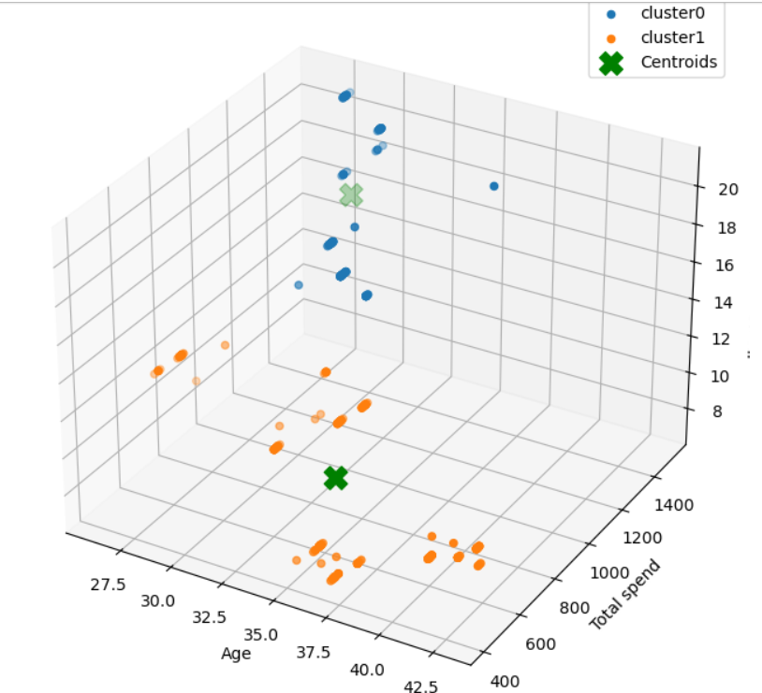

AGGLOMERATIVE CLUSTERING
x=df1[['Age','Total Spend','Items Purchased']].values
from sklearn.cluster import KMeans, AgglomerativeClustering as clus
from scipy.cluster.hierarchy import dendrogram, linkage
ag = clus(n_clusters=k, linkage='complete')
df1['agg'] = ag.fit_predict(x)
l = linkage(x, method='complete')
plt.figure(figsize=(15, 5))
dendrogram(l, orientation='top', distance_sort='descending', show_leaf_counts=True)
plt.title("Dendrogram for Agglomerative Clustering")
plt.xlabel("Data Points")
plt.xticks([])
plt.ylabel("Euclidean Distance")
plt.show()
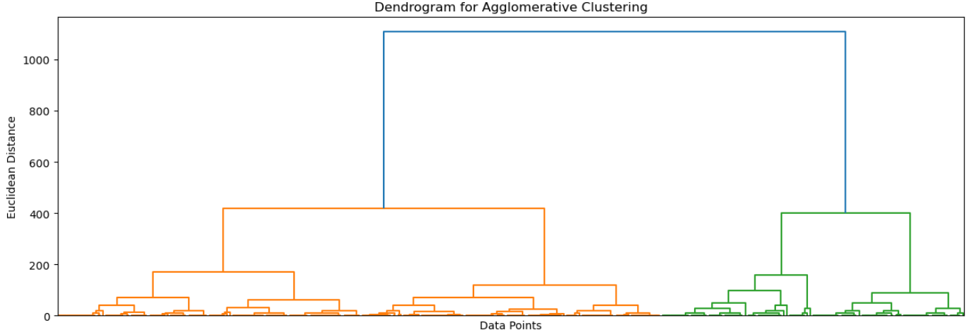
INFERENCE:
K-Means is better when you want distinct, non-overlapping customer segments and need to analyze customer spending patterns quickly. The two clustering methods (K-Means and Agglomerative Clustering) produce similar results in terms of grouping data, but they differ in approach.

DATA BRUSHING (SLICING)
def hs(df,th):
h=df[df['Total Spend']>th]
return h
h=hs(df1,1100)
others = df1[df1['Total Spend'] <= 1100]
plt.scatter(h['Age'], h['Total Spend'], color='red', label='High Spenders')
plt.scatter(others['Age'], others['Total Spend'], color='blue', label='Other Customers')
plt.xlabel("Age")
plt.ylabel("Total Spend")
plt.title("Scatter Plot of High Spenders ")
plt.legend()
plt.show()
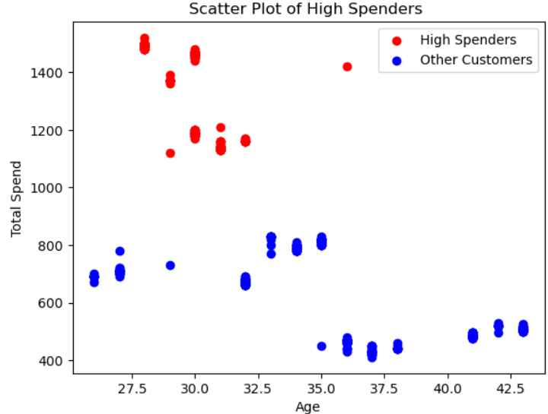
INFERENCE:
Younger customers tend to be high spenders. Older customers are generally lower spenders.

NEARNESS SELECTION
def find(df, ti, th):
target = df.iloc[ti][['Total Spend', 'Items Purchased']].to_numpy().reshape(1, -1)
data = df[['Total Spend', 'Items Purchased']].to_numpy(dtype=np.float64)
target = target.astype(np.float64).flatten()
d = np.linalg.norm(data - target, axis=1)
near = df[(d <= th) & (d > 0)]
return near, target
def plot(df, ti, th):
near, target = find(df, ti, th)
plt.figure(figsize=(8, 5))
plt.scatter(df['Total Spend'], df['Items Purchased'], color='gray', alpha=0.5, label='Other Customers')
plt.scatter(near['Total Spend'], near['Items Purchased'], color='blue', label='Nearby Customers', edgecolors='k')
plt.scatter(target[0], target[1], color='red', label='Target Customer', s=100, edgecolors='black')
plt.xlabel("Total Spend")
plt.ylabel("Items Purchased")
plt.title("Target Customer & Nearby Customers")
plt.legend()
target = 10
th = 200
plot(df1, target, th)
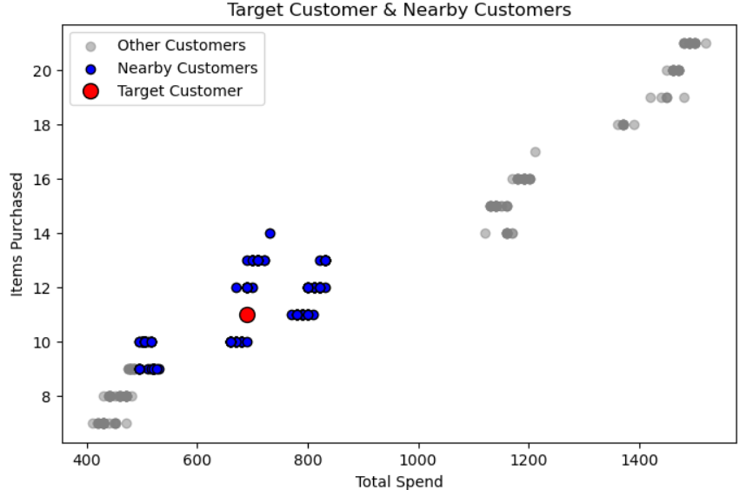
SORTING & REARRANGING
df1=pd.read_csv(r"C:\Users\hanal\Desktop\E-commerce Customer Behavior - Sheet1.csv")
def sort(df):
d1=df.sort_values(by='Total Spend',)
d2=df.sort_values(by='Items Purchased',ascending=False)
d3=df.sort_values(by='Age')
return d1 ,d2 ,d3
d1,d2,d3=sort(df1)
print('sorted by total spend')
d1.head()

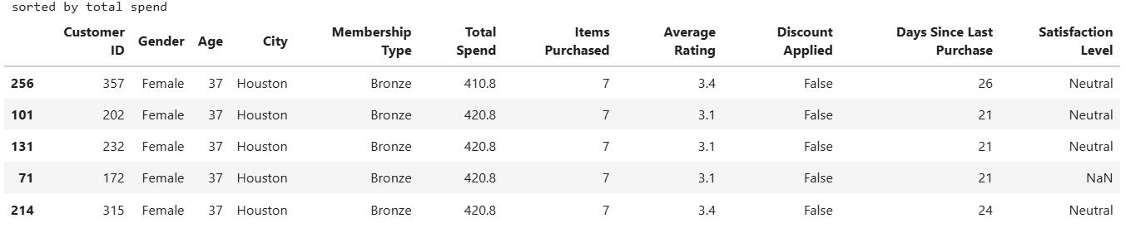
print('sorted by items purchased')
d2.head()

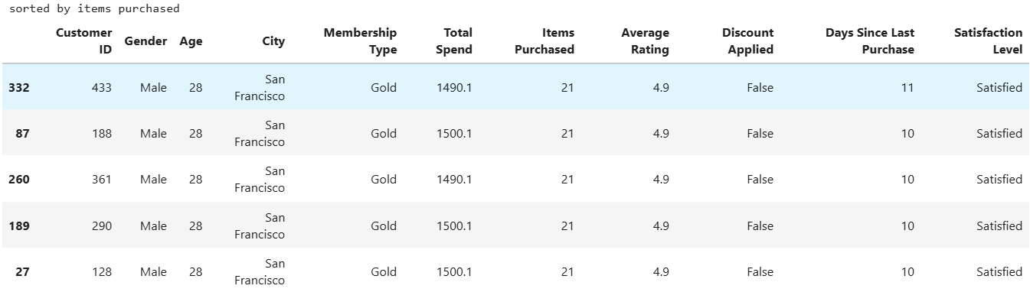
print("sort by age")
d3.head()

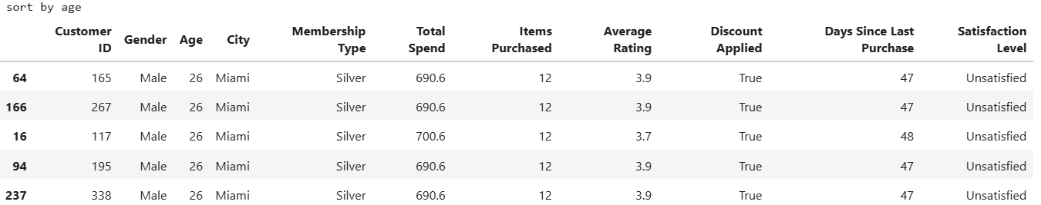

RESULT:
We have performed Data and Cluster Analysis on Happiness & E-Commerce
EX. NO: 10  03 .04 .25 | DATA VISUALISATION
AIM:
To perform 2D/3D data visualization on mtcars dataset and advanced data visualization .

SIMPLE VISUALISATION:
import pandas as pd
df=pd.read_csv(r"C:\Users\hanal\Desktop\mtcars.csv")
df=df.rename(columns={df.columns[0]:"model"})
df.head()
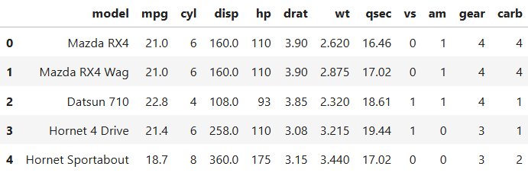
CODE:
import seaborn as sns
import matplotlib.pyplot as plt
plt.plot(df.index,df['hp'])
plt.xlabel('INDEX')
plt.ylabel('hp')
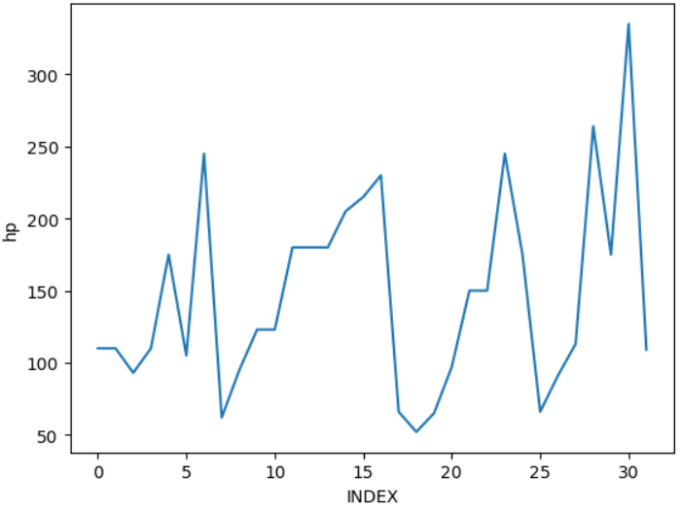
INFERENCE:
There are several sharp peaks and drops, indicating high variance in engine power.

CODE:
sns.scatterplot(x=df['mpg'],y=df['hp'])
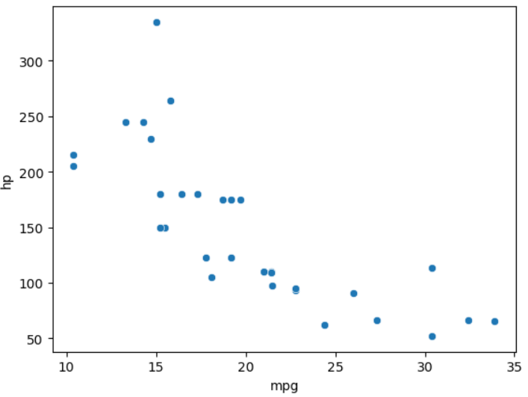
INFERENCE:
High-performance cars (high hp) usually consume more fuel, resulting in lower mpg.
CODE:
sns.scatterplot(x=df['wt'],y=df['hp'])

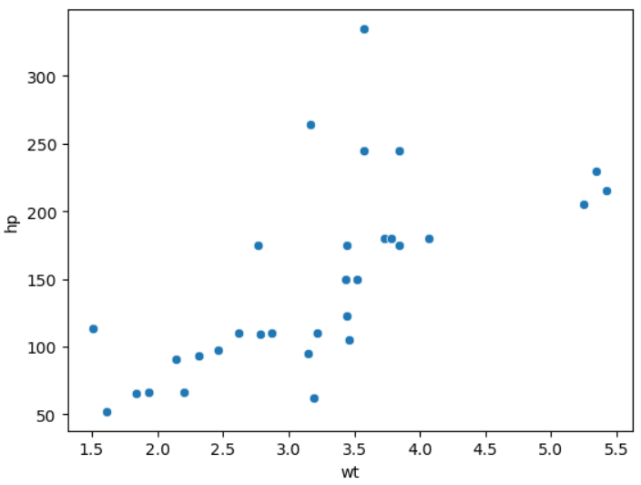
INFERENCE:
There is a clear negative correlation: as horsepower increases, mpg decreases

CODE:
error=0.1*df['hp']
import matplotlib.pyplot as plt
plt.errorbar(df['hp'],df['mpg'],xerr=error,fmt='s',capsize=5)
plt.ylabel('mpg')
plt.xlabel('hp')

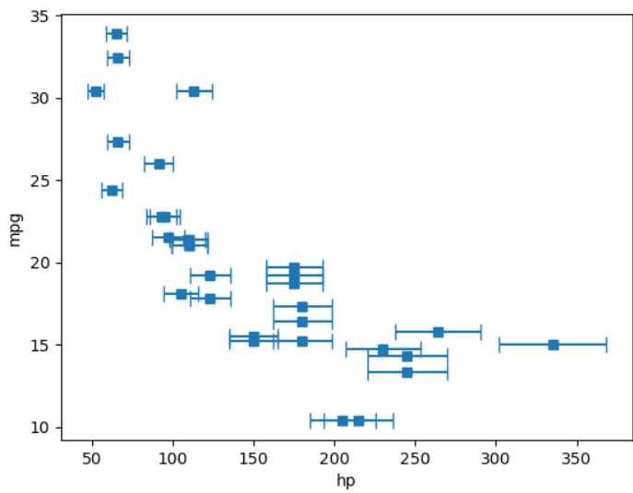
INFERENCE:
Vehicles with high mpg (~30+) tend to have low hp (~50–100) with tight error bars

CODE:
from scipy.interpolate import griddata
import numpy as np
h,w=np.meshgrid(np.linspace(df['hp'].min(),df['hp'].max(),100),np.linspace(df['wt'].min(),df['wt'].max(),100))
m=griddata((df['hp'],df['wt']),df['mpg'],(h,w),method='cubic')
c=plt.contourf(h,w,m,cmap='coolwarm',levels=20)
plt.colorbar(c,label='MPG (Fuel Efficiency)')
plt.xlabel('hp')
plt.ylabel('wt')
plt.title('Contour plot for fuel efficiency')
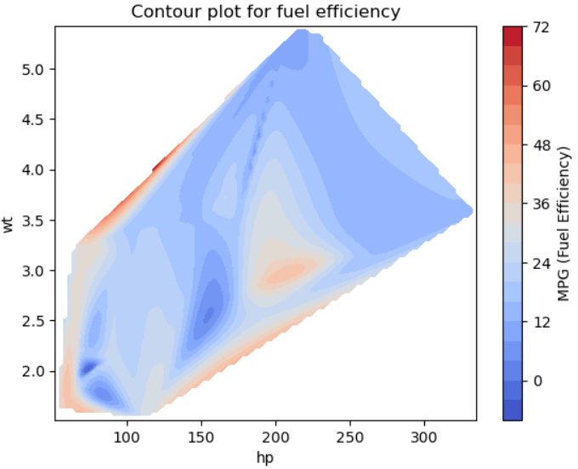
INFERENCE:
To maximize MPG, a vehicle should have lower horsepower and lighter weight.

DATA DISTRIBUTION VISUALISATION:
plt.figure(figsize=(12,4))
plt.subplot(131)
plt.title('histogram with 5 bins')
plt.xlabel('mpg')
plt.ylabel('frequency')
plt.hist(df['mpg'],bins=5,edgecolor='black')
plt.subplot(132)
plt.title('histogram with 10 bins')
plt.xlabel('mpg')
plt.ylabel('frequency')
plt.hist(df['mpg'],bins=10,edgecolor='black')
plt.subplot(133)
plt.title('histogram with 15 bins')
plt.xlabel('mpg')
plt.ylabel('frequency')
plt.hist(df['mpg'],bins=15,edgecolor='black')
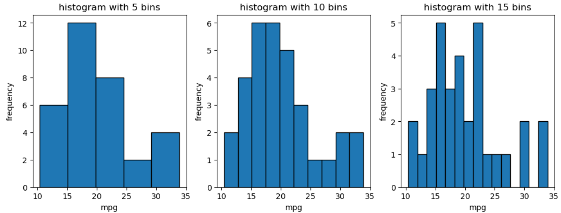
INFERENCE:
Increasing the number of bins makes the histogram more detailed
CODE:
hp_avg = df.groupby('cyl')['hp'].mean()
plt.figure(figsize=(8, 5))
plt.plot(hp_avg.index, hp_avg.values, marker='o', linestyle='-', color='b', label='Avg HP')
plt.legend(['Avg Horsepower'], loc='upper left', fontsize=12, facecolor='lightgray', edgecolor='black')
plt.xlabel('Cylinders')
plt.ylabel('Average of Horsepower')
plt.title('Comparison of Horsepower across Different Cylinders')
plt.grid(True)
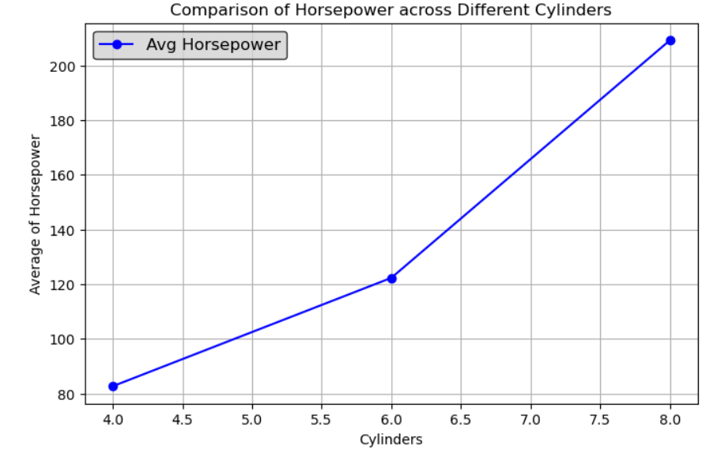
INFERENCE:
Horsepower increases with cylinders. When cylinders are high , the hp also high.

ADVANCED DATA VISUALIZATION ON VIDEO GAMES SALES
CODE:
df=pd.read_csv(r"C:\Users\hanal\Desktop\Video_Games_Sales_as_at_22_Dec_2016.csv")
df.head()
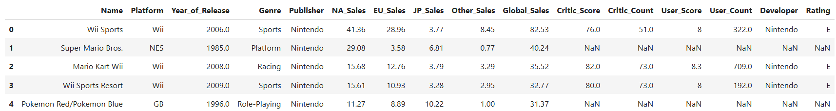

CODE:
g = df.groupby('Genre')['Global_Sales'].sum()
y = df.groupby('Year_of_Release')['Global_Sales'].sum()
df['Critic_Score'] = pd.to_numeric(df['Critic_Score'], errors='coerce')
df['User_Score'] = pd.to_numeric(df['User_Score'], errors='coerce')
df_clean = df.dropna(subset=['Critic_Score', 'User_Score'])
fig,axes=plt.subplots(2,2,figsize=(20,8))
axes[0,0].bar(g.index,g.values,edgecolor='black')
axes[0,0].set_ylabel('global sales by genre')
axes[0,0].set_xlabel('index')
axes[0,1].scatter(df['NA_Sales'],df['EU_Sales'] )
axes[0,1].set_ylabel('EU_Sales')
axes[0,1].set_xlabel('NA_Sales')
axes[1,0].plot(y.index,y.values)
axes[1,0].set_xlabel('index')
axes[1,0].set_ylabel('global sales by year')
hb = axes[1,1].hexbin(df_clean['Critic_Score'], df_clean['User_Score'], gridsize=25, cmap='Blues', mincnt=1)
fig.colorbar(hb,label='count')
axes[1,1].set_xlabel('Critic_Score')
axes[1,1].set_ylabel('User_Score')
plt.tight_layout()
plt.show()
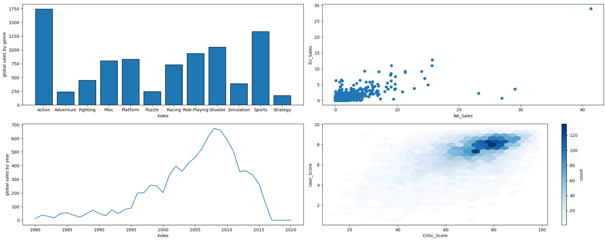
INFERENCE:
Action games are top sellers, with market focus in NA and EU. Sales peaked around 2010. User and critic ratings are generally aligned for most games.
CODE:
from matplotlib.ticker import FuncFormatter
def l(x, pos):
return f"{int(x):,}"
df['Name'] = df['Name'].astype(str)
df_sorted = df.sort_values(by="Global_Sales", ascending=False).head(50)
df_sorted["Global_Sales"] = (df_sorted["Global_Sales"] * 1_000_000).astype(int)
top_game = df_sorted.iloc[0]
plt.figure(figsize=(20, 10))
plt.bar(df_sorted["Name"], df_sorted["Global_Sales"])
plt.annotate(f"{top_game['Name']} ({top_game['Global_Sales']:,})", xy=(0, top_game["Global_Sales"]),xytext=(5, top_game["Global_Sales"] + 5_000_000), arrowprops=dict(facecolor='red', arrowstyle='->'), fontsize=10)
plt.gca().yaxis.set_major_formatter(FuncFormatter(l))
plt.xlabel('Game', fontsize=12)
plt.ylabel('Total Sales (Units)', fontsize=12)
plt.title('Total Sales of Top 50 Games', fontsize=14)
plt.xticks(rotation=45,ha='right', fontsize=10)
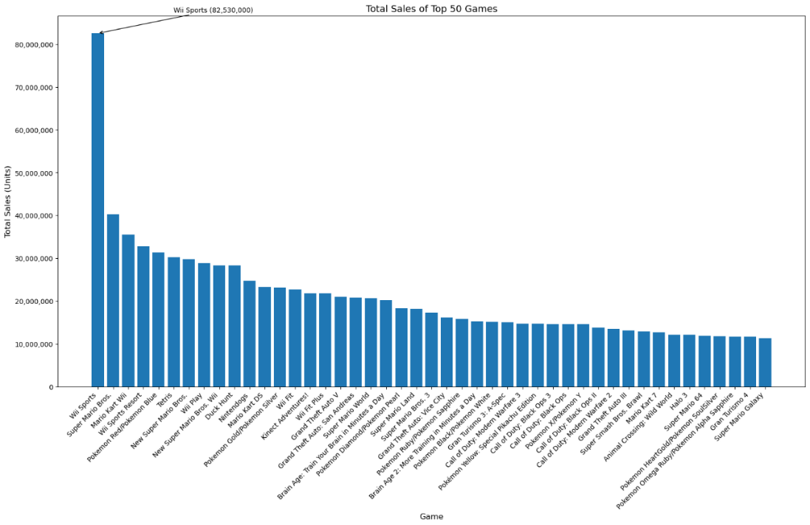
INFERENCE:
Wii Sports leads by a huge margin with 82.53 million units sold.

CODE:
low_critic_threshold = 60
high_sales_threshold = 25
df['Name'] = df['Name'].astype(str)
outliers = df[(df['Critic_Score'] < low_critic_threshold) & (df['Global_Sales'] > high_sales_threshold)]
plt.figure(figsize=(10, 6))
plt.scatter(df["Critic_Score"], df["Global_Sales"], color="lightblue", alpha=0.5, label="Games")
plt.scatter(outliers["Critic_Score"], outliers["Global_Sales"], color="red", label="Outliers", edgecolors="black", s=100)
for index, row in outliers.iterrows():
plt.annotate(row["Name"], (row["Critic_Score"], row["Global_Sales"]), fontsize=9, xytext=(5,5), textcoords="offset points")
plt.xlabel("Critic Score", fontsize=12)
plt.ylabel("Global Sales (Millions)", fontsize=12)
plt.title("Outliers: Games with Low Critic Scores but High Sales", fontsize=14)
plt.axvline(low_critic_threshold, color="gray", linestyle="--", label="Low Critic Score Threshold")
plt.axhline(high_sales_threshold, color="green", linestyle="--", label="High Sales Threshold")
plt.legend()
plt.show()
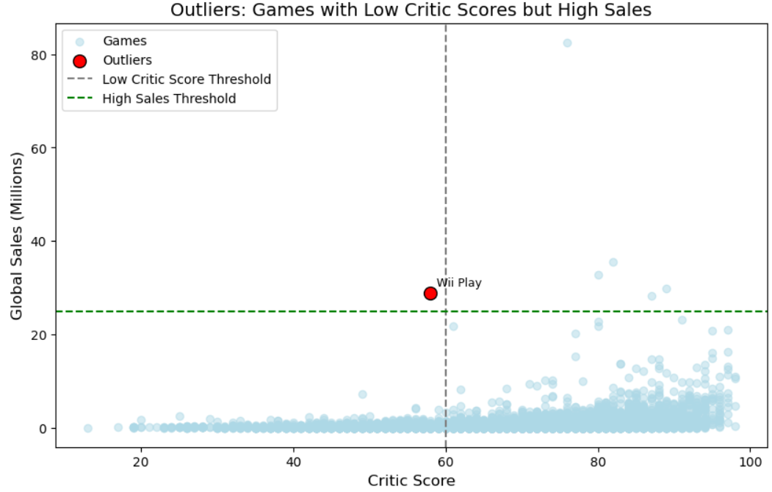
INFERENCE:
"Wii Play" is a notable exception where commercial success did not align with critical reception. Most games with low critic scores tend to have low sales, making such cases rare.

CODE:
import pandas as pd
import matplotlib.pyplot as plt
df['Year_of_Release'] = pd.to_numeric(df['Year_of_Release'], errors='coerce')
df_sorted = df.sort_values(by="Global_Sales", ascending=False).head(50)
sales_by_year = df_sorted.groupby("Year_of_Release")["Global_Sales"].sum()
styles = ["fivethirtyeight", "seaborn-v0_8-poster", "grayscale"]
fig, axes = plt.subplots(1, 3, figsize=(18, 5), sharey=True)
for ax, style in zip(axes, styles):
plt.style.use(style)
ax.plot(sales_by_year.index, sales_by_year.values, marker='o', linestyle='-')
ax.set_title(f"Style: {style}")
ax.set_xlabel("Year of Release")
ax.set_ylabel("Global Sales (Millions)")
plt.tight_layout()
plt.show()
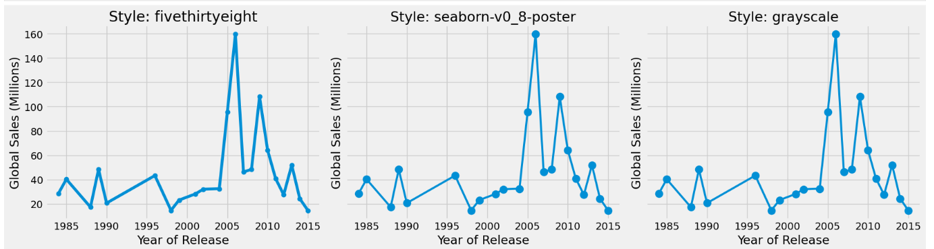
INFERENCE:
The 2006 peak might align with the release of consoles like the Nintendo Wii, PlayStation 3, or Xbox 360, which were industry-shifting platforms. Post-2010 decline could reflect a transition toward digital distribution, mobile gaming, or changes in consumer behavior.

CODE:
from mpl_toolkits.mplot3d import Axes3D
df['Year_of_Release'] = pd.to_numeric(df['Year_of_Release'], errors='coerce')
df = df.dropna(subset=['Year_of_Release', 'Global_Sales', 'Critic_Score', 'Genre'])
df['Year_Binned'] = (df['Year_of_Release'] // 5) * 5
genres = df['Genre'].unique()
color_map = dict(zip(genres, sns.color_palette("tab10", len(genres))))
df['Color'] = df['Genre'].map(color_map)
fig = plt.figure(figsize=(12, 8))
ax = fig.add_subplot(111, projection='3d')
scatter = ax.scatter(df['Year_Binned'], df['Global_Sales'], df['Critic_Score'], c=df['Color'], s=40, alpha=0.7)
ax.set_title("3D Scatter: Year vs. Sales vs. Critic Score")
years = np.arange(int(df['Year_Binned'].min()), int(df['Year_Binned'].max()) + 5, 5)
ax.set_xticks(years)
ax.set_xticklabels(years, rotation=45)
handles = [plt.Line2D([0], [0], marker='o', color='w', markersize=8, markerfacecolor=color_map[g]) for g in genres]
ax.legend(handles, genres, title="Genres", loc="upper right",fontsize='small')
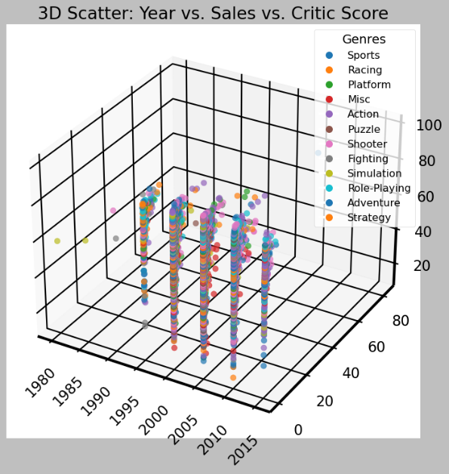

INFERENCE:
Best-selling games are often in mainstream genres and released during market boom years (like 2006–2010). Critically acclaimed games aren’t always bestsellers, especially if they belong to less popular genres.

CODE:
import geopandas as gpd
region_sales = {'North America': df['NA_Sales'].sum(), 'Europe': df['EU_Sales'].sum(), 'Japan': df['JP_Sales'].sum(),}
region_sales_df = pd.DataFrame(list(region_sales.items()), columns=['Region', 'Sales'])
world = gpd.read_file(r"C:\Users\hanal\Desktop\ne_110m_admin_0_countries.shp")
region_mapping = { 'United States': 'North America','Canada': 'North America','Mexico': 'North America', 'United Kingdom': 'Europe', 'Germany': 'Europe','France': 'Europe',‘Italy': 'Europe','Spain': 'Europe','Russia': 'Europe','Japan': 'Japan' }
world['Region'] = world['ADMIN'].map(region_mapping).fillna('Other')
world['Sales'] = world['Region'].map(region_sales).fillna(0)
fig, ax = plt.subplots(figsize=(15, 10))
world.plot(column='Sales', ax=ax, legend=True, cmap='coolwarm', legend_kwds={'label': "Sales by Region", 'orientation': "horizontal"})
annotated_regions = set()
for idx, row in world.iterrows():
region = row['Region']
if row['Sales'] > 0 and region not in annotated_regions:
xy = row['geometry'].centroid.coords[0]
ax.annotate(f"{region}\n${row['Sales']:,.2f}",
xy=xy, xytext=(3, 3), textcoords="offset points",
ha='center', fontsize=10, color='black', weight='bold')
annotated_regions.add(region)
strongest = region_sales_df.loc[region_sales_df['Sales'].idxmax()]
weakest = region_sales_df.loc[region_sales_df['Sales'].idxmin()]
ax.annotate(f"Strongest: {strongest['Region']} (${strongest['Sales']:,.2f})",
xy=(0.7, 0.9), xycoords="axes fraction", fontsize=12,
color="darkgreen", weight="bold", bbox=dict(facecolor='white', alpha=0.7))
ax.annotate(f"Weakest: {weakest['Region']} (${weakest['Sales']:,.2f})",
xy=(0.7, 0.8), xycoords="axes fraction", fontsize=12,
color="darkred", weight="bold", bbox=dict(facecolor='white', alpha=0.7))
plt.title('Total Sales by Region', fontsize=16)
plt.show()

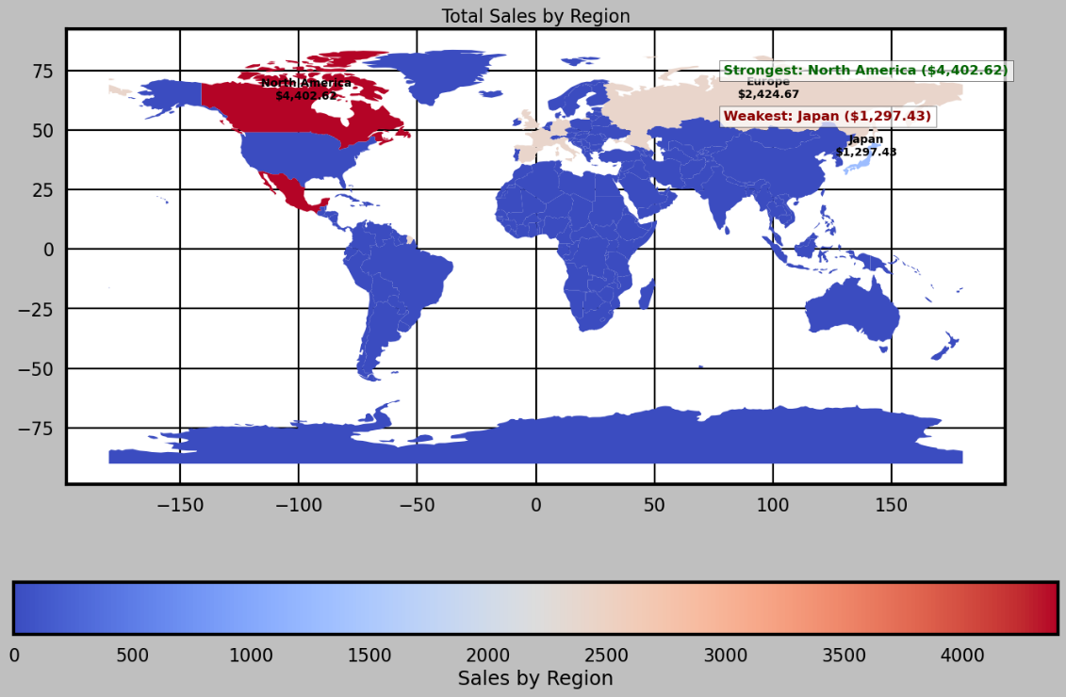

RESULT:
We have performed 2D/3D data visualization on mtcars dataset and advanced data visualization .

EX. NO: 11  07 .04 .25 | TEXT AND DOCUMENT VISUALIZATION AND TEXT ANALYSIS AND VISUALIZATION SYSTEMS
AIM:
To perform text and document visualization and text analysis and visualization systems
TEXT AND DOCUMENT VISUALIZATION
import pandas as pd
df=pd.read_csv(r"C:\Users\student\Desktop\Movies_Reviews_modified_version1.csv")
df.head()
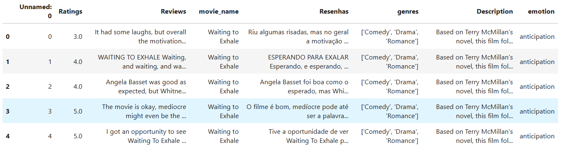
CODE:
from wordcloud import WordCloud, STOPWORDS
from collections import Counter
import matplotlib.pyplot as plt
from wordcloud import STOPWORDS
import re
movie_name ="Robin Hood"
reviews = df[df['movie_name'].str.lower() == movie_name.lower()]
text = " ".join(str(i) for i in reviews['Reviews'])
words = re.findall(r'\b[a-z]+\b', text.lower()) # Only alphabetic words
custom_stopwords = set(STOPWORDS)
custom_stopwords.update(["movie", "film","the" ])
custom_stopwords.update(movie_name.lower().split())
wordcloud = WordCloud(stopwords=custom_stopwords, background_color="white", width=800, height=400).generate(text)
plt.figure(figsize=(15, 7))
plt.imshow(wordcloud, interpolation='bilinear')
plt.axis("off")
plt.title(f"Word Cloud - {movie_name} Reviews", fontsize=18)


CODE:
from nltk.corpus import stopwords
import nltk
import math
nltk.download('stopwords')
stop_words = set(stopwords.words('english'))
custom_stopwords = stop_words.union({'movie', 'film','the','one','movie','time','much','also','get','like','two','story'}) # Add your custom stopwords if needed
def tokenize(text):
tokens = re.findall(r'\b[a-z]+\b', str(text).lower())
return [word for word in tokens if word not in custom_stopwords]
emotion_colors = {'joy': 'blue', 'sadness': 'orange'}
emotions = df['emotion'].dropna().unique()
num_emotions = len(emotions)
cols = 2
rows = math.ceil(num_emotions / cols)
fig, axes = plt.subplots(rows, cols, figsize=(15, rows * 5))
axes = axes.flatten()
for idx, emotion in enumerate(emotions):
reviews = df[df['emotion'] == emotion]['Reviews']
all_words = []
for review in reviews:
all_words.extend(tokenize(review))
top_words = Counter(all_words).most_common(15)
if top_words:
words, counts = zip(*top_words)
color = emotion_colors.get(emotion, 'gray')
ax = axes[idx]
ax.bar(words, counts, color=color)
ax.set_title(f"{emotion.capitalize()} - Top 15 Words", fontsize=12)
ax.set_xticklabels(words, rotation=45)
ax.set_ylabel("Frequency")
else:
axes[idx].set_visible(False)
for j in range(idx + 1, len(axes)):
axes[j].set_visible(False)
plt.tight_layout()
plt.show()
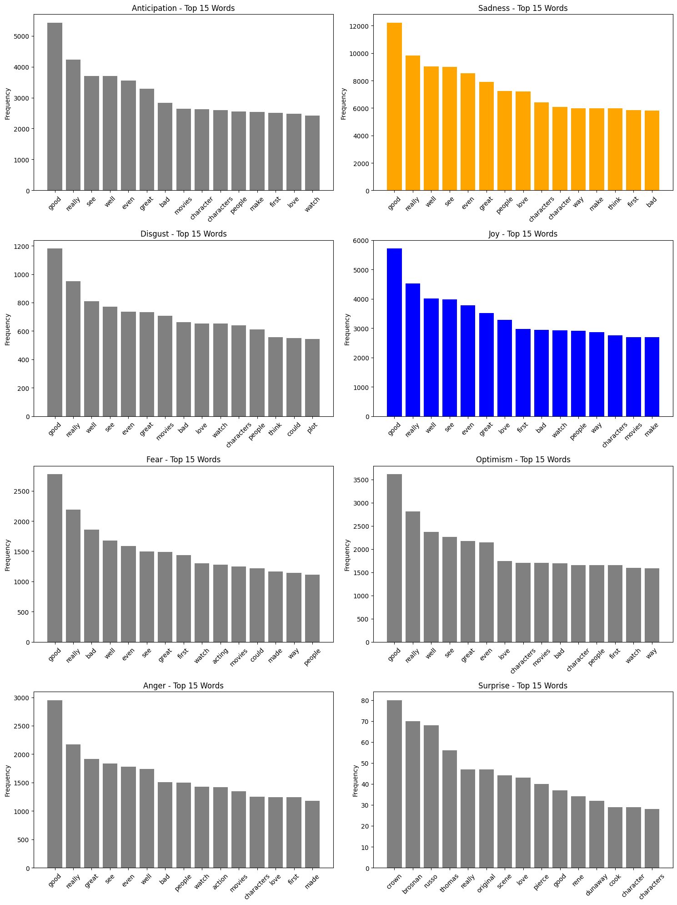
INFERENCE:
The image visualizes how frequently specific words appear in texts associated with different emotions. While many words are common across categories, each emotion also has unique linguistic indicators. The overlap implies that sentiment/emotion classification often depends on context and word usage patterns

GENRE-BASED SENTIMENT HEATMAP
df['genres'] = df['genres'].apply(lambda x: eval(x) if isinstance(x, str) else x)
df_exploded = df.explode('genres')
target_genres = ['Action', 'Comedy', 'Drama', 'Thriller', 'Romance']
df_filtered = df_exploded[df_exploded['genres'].isin(target_genres)]
heatmap_data = df_filtered.pivot_table(index='genres', columns='emotion', values='Ratings', aggfunc='mean')
plt.figure(figsize=(10, 6))
sns.heatmap(heatmap_data, annot=True, fmt=".2f", cmap='coolwarm', linewidths=0.5)
plt.title("2D Heatmap: Average Sentiment by Genre and Emotion")
plt.xlabel("Emotion")
plt.ylabel("Genre")
plt.show()

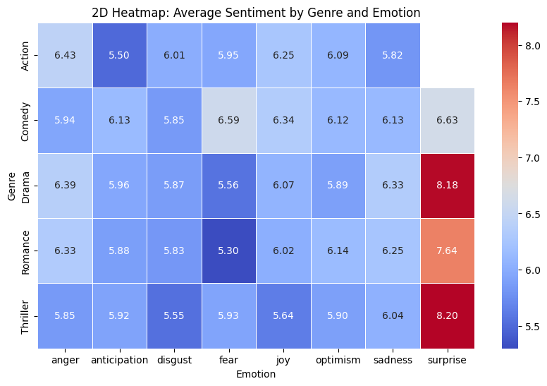
INFERENCE:
Surprise is a highly valued emotional cue, especially in thrillers and dramas. Negative emotions (like fear and disgust) elicit lower sentiment scores, especially in genres not typically associated with intensity.

COMPARING VISUALIZATION TECHNIQUES:
Word cloud : Faster for getting a general idea .Bar chart: better for visualising, camparison . Bar Chart is better — when it comes to interpreting data accurately and quickly.

TEXT ANALYSIS AND VISUALIZATION SYSTEMS

CODE:
df=pd.read_csv("text_complexity_summarization.csv")
df.head()
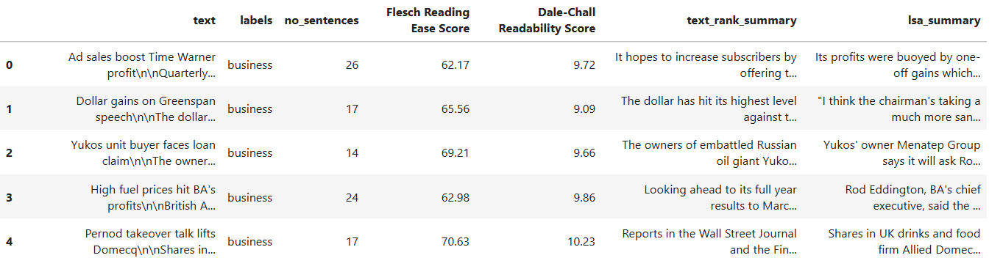
CODE:
from sklearn.feature_extraction.text import TfidfVectorizer
custom_stopwords = set([
'mr','the', 'and', 'to', 'of', 'a', 'in', 'for', 'on', 'with', 'as', 'at','mr'
'by', 'from', 'it', 'this', 'that', 'is', 'are', 'was', 'be', 'an',
'or', 'not', 'have', 'has', 'had', 'will', 'would', 'can', 'could',
'also', 'may', 'been', 'were', 'more', 'his', 'her', 'he', 'she',
'we', 'they', 'you', 'i', 'them', 'their', 'our', 'us', 'who', 'which',
'but', 'said', 'mr', 'mrs', 'one', 'two', 'new', 'year', 'make', 'like','said','mr'
])
categories = df['labels'].unique()
custom_stop_words = list(text.ENGLISH_STOP_WORDS.union(my_extra_stopwords))
vectorizer = TfidfVectorizer(stop_words=custom_stop_words, max_features=1000)
fig, axes = plt.subplots(len(categories), 1, figsize=(10, 5 * len(categories)))
if len(categories) == 1:
axes = [axes]
df['text'] = df['text'].astype(str).fillna('')
texts = df[df['labels'] == category]['text']
tfidf_matrix = vectorizer.fit_transform(texts)
tfidf_scores = tfidf_matrix.mean(axis=0).A1
terms = vectorizer.get_feature_names_out()
term_scores_df = pd.DataFrame({'term': terms, 'score': tfidf_scores})
top_terms = term_scores_df.sort_values(by='score', ascending=False).head(10)
sns.barplot(x='score', y='term', data=top_terms, ax=axes[i], palette="viridis")
axes[i].set_title(f"Top 10 TF-IDF Terms for '{category}'", fontsize=14)
axes[i].set_xlabel("TF-IDF Score")
axes[i].set_ylabel("Term")
plt.tight_layout()
plt.show()

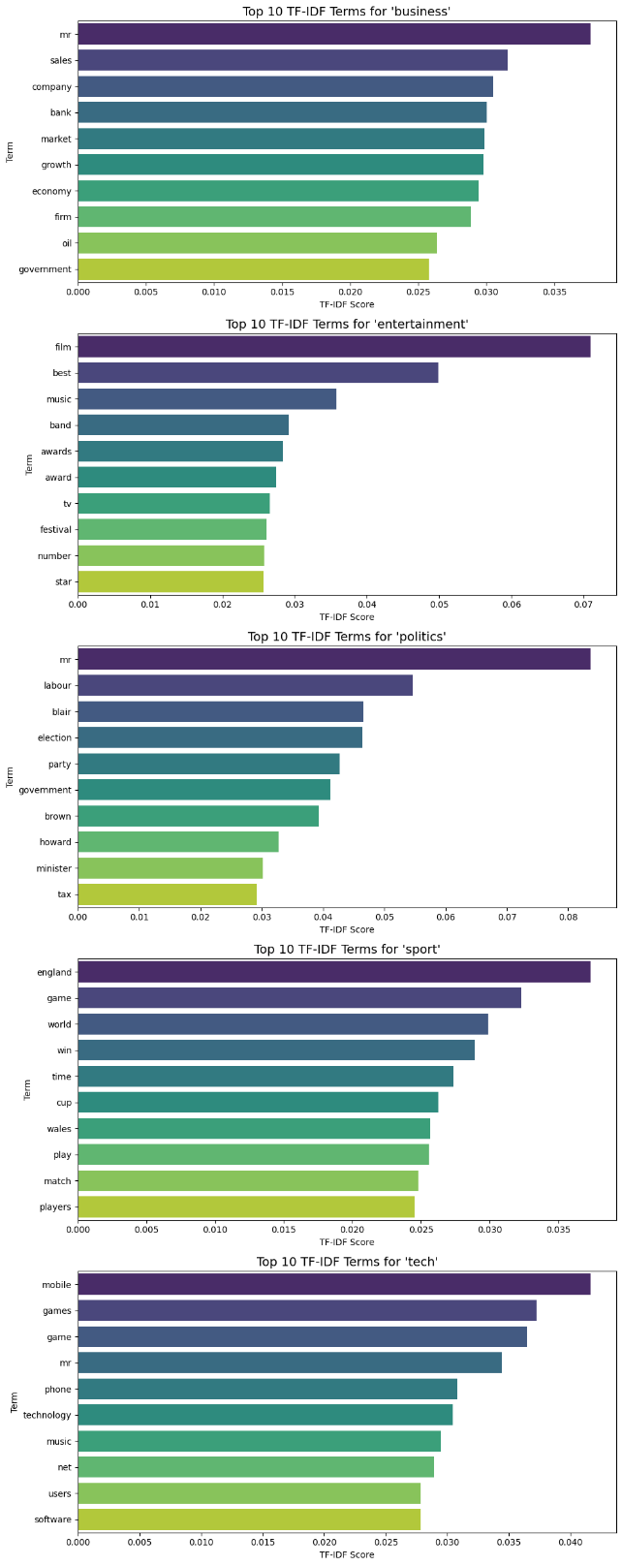

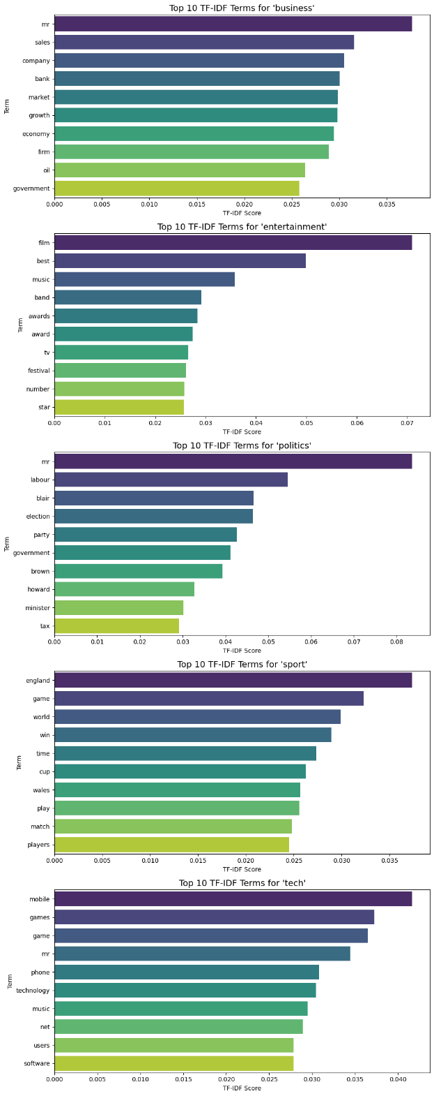
INFERENCE:
Overlap term: game appears in both lists, showing cross-topic relevance.
Distinct Focus:
- Sport: driven by event-based, team-related terms.
- Tech: emphasizes gadgets, usage, and digital content.
TF-IDF range: Higher max values in tech

CODE:
from sklearn.feature_extraction.text import CountVectorizer
from sklearn.decomposition import TruncatedSVD
from sklearn.metrics.pairwise import cosine_similarity
docs = df['text'].dropna().tolist()[:500]
def clean_text(text):
text = text.lower()
text = re.sub(r'[^a-z\s]', '', text)
return text
cleaned_docs = [clean_text(doc) for doc in docs]
vectorizer = CountVectorizer(stop_words='english')
X = vectorizer.fit_transform(cleaned_docs)
terms = vectorizer.get_feature_names_out()
n_features = X.shape[1]
n_components = min(100, n_features - 1)
svd = TruncatedSVD(n_components=n_components)
X_reduced = svd.fit_transform(X.T)
word_embeddings = {term: X_reduced[i] for i, term in enumerate(terms)}
def get_similar_words(word, topn=5):
if word not in word_embeddings:
print(f"'{word}' not found in vocabulary.")
return []
word_vec = word_embeddings[word].reshape(1, -1)
all_words = list(word_embeddings.keys())
all_vecs = np.array([word_embeddings[w] for w in all_words])
sims = cosine_similarity(word_vec, all_vecs)[0]
top_indices = sims.argsort()[-topn-1:][::-1][1:]
return [(all_words[i], round(sims[i], 3)) for i in top_indices]
target_word = "sales"
print(f"\nTop similar words to '{target_word}':")
similar = get_similar_words(target_word)
for word, score in similar:
print(f"{word}: {score}")
OUTPUT:
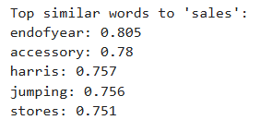

CODE:
import re
import matplotlib.pyplot as plt
from sklearn.feature_extraction.text import CountVectorizer
from sklearn.decomposition import LatentDirichletAllocation
docs = df['text'].dropna().tolist()[:50]
def clean_text(text):
text = text.lower()
text = re.sub(r'[^a-z\s]', '', text)
return text
cleaned_docs = [clean_text(doc) for doc in docs]
vectorizer = CountVectorizer(stop_words='english', max_features=1000)
X = vectorizer.fit_transform(cleaned_docs)
lda = LatentDirichletAllocation(n_components=3, random_state=42)
lda_topic_distributions = lda.fit_transform(X)
fig, ax = plt.subplots(figsize=(12, 6))
topic_probs = lda_topic_distributions.T
colors = ['#FF6F61', '#6B5B95', '#88B04B']
for i in range(3): # 3 topics
ax.bar(range(len(cleaned_docs)), topic_probs[i], bottom=np.sum(topic_probs[:i], axis=0), color=colors[i], label=f"Topic {i+1}")
ax.set_title("Topic Distribution per Article")
ax.set_xlabel("Article Index")
ax.set_ylabel("Topic Proportion")
ax.legend()
plt.tight_layout()
plt.show()
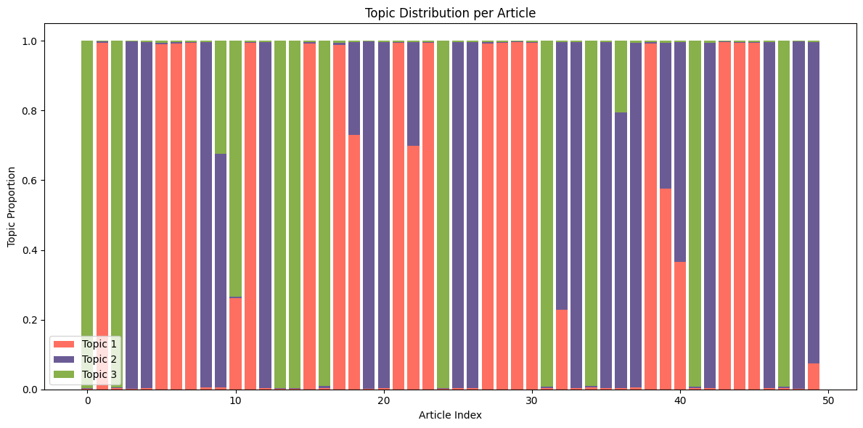
INFERENCE:
The chart shows the topic distribution across 50 articles. Each bar represents one article, and the colors indicate the proportion of three different topics. Topic 1 (red) is the most dominant in most articles

CODE:
import networkx as nx
from itertools import combinations
from collections import defaultdict
def clean_text(text):
text = text.lower()
text = re.sub(r'[^a-z\s]', '', text)
return text
docs = df['text'].apply(clean_text)
vectorizer = CountVectorizer(stop_words='english', max_features=2000)
X = vectorizer.fit_transform(docs)
terms = vectorizer.get_feature_names_out()
lda = LatentDirichletAllocation(n_components=3, random_state=42)
lda.fit(X)
topic_keywords = {}
top_words = 5
for idx, topic in enumerate(lda.components_):
top_indices = topic.argsort()[-top_words:][::-1]
topic_keywords[f'Topic {idx+1}'] = [terms[i] for i in top_indices]
co_occurrence = defaultdict(int)
for row in X.toarray():
words_in_doc = [terms[i] for i, val in enumerate(row) if val > 0]
for w1, w2 in combinations(words_in_doc, 2):
pair = tuple(sorted((w1, w2)))
co_occurrence[pair] += 1
topic_words_flat = [word for words in topic_keywords.values() for word in words]
edges = [(w1, w2, freq) for (w1, w2), freq in co_occurrence.items()
if (w1 in topic_words_flat or w2 in topic_words_flat) and freq > 5]
G = nx.Graph()
for w1, w2, freq in edges:
G.add_edge(w1, w2, weight=freq)
top_nodes = sorted(G.degree, key=lambda x: x[1], reverse=True)[:30]
G = G.subgraph([n for n, _ in top_nodes])
color_map = {
'Topic 1': 'tomato', 'Topic 2': 'skyblue','Topic 3': 'lightgreen', 'Other': 'lightgray'}
node_colors = []
for node in G.nodes():
assigned = False
for topic, words in topic_keywords.items():
if node in words:
node_colors.append(color_map[topic])
assigned = True
break
if not assigned:
node_colors.append(color_map['Other'])
plt.figure(figsize=(12, 8))
pos = nx.spring_layout(G, seed=42)
nx.draw(G, pos, with_labels=True, node_color=node_colors, edge_color='gray', node_size=1000,font_size=9, width=2)
plt.title("🕸️ Co-occurrence Network Colored by Extracted LDA Topics")
plt.tight_layout()
plt.show()

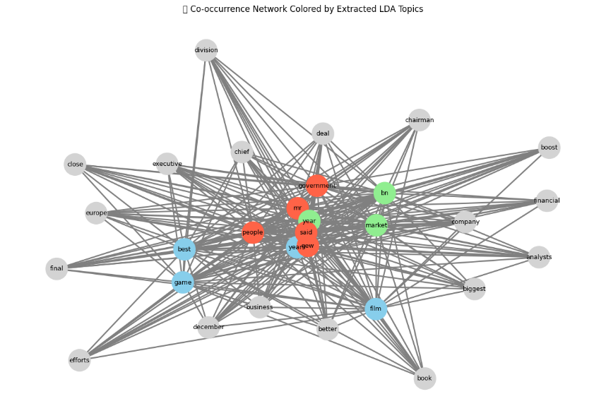
INFERENCE:
This co-occurrence network visualizes word relationships based on LDA topic modeling. Nodes represent words, and edges show their co-occurrence in the same context. Colored nodes indicate different topics—red, blue, and green highlight clusters of related terms. Most central words like "said" and "mr" appear in the red cluster, showing strong topic relevance

RESULT:
We have performed text and document visualization and text analysis and visualization systems

